Oklahoma Business Ethics Consortium
December 14, 2005 ~ 11:30 to 1:00
Agenda

I. Welcome & Announcements 11:40
- Shannon Warren
OkEthics Founding Director

II. Kudos
    - Connie Barwick, Dept. of Corrections (AV & PowerPoint)
    - Debbie Gardner, Accel Financial Staffing (CPE Credits)
    - Ron Hulshizer (IMA Co-Sponsor)
    - Tammy Wood, Valir Health (Nametags)

III. Request:
Associate General Counsel to serve on OkEthics Foundation Board of Directors

IV. Upcoming Consortium Meetings

OKC Chapter

January 11 – Back by popular demand!
Tom Hill, COO of Kimray, “Character Initiatives”
Hosted next door by the Character First Institute

February 8 – Watch for this announcement!
We are “buzzing” about our speaker for this event!

MOORE-NORMAN CHAPTER MEETING:
Members in OKC chapter may participate in other Chapter activities at the regular member rate. To make reservations, visit our website at www.okethics.org

December 21 – OU Hosts Meeting on Philanthropy: “Doing Good While Feeling Good”
Presented by Von Allen

TULSA CONSORTIUM MEETINGS:
January 26 – “Ethical Leadership: A View from the Dark Side” by Dr. Robert Hogan,
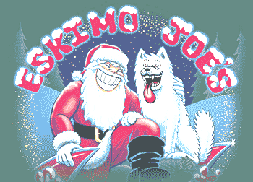
Hogan Assessments

March 23 – Stan Clark, Eskimo Joe’s

Other Programs Related to Ethics
Character First – Business Leaders Breakfast/Luncheon
Topic: “Punctuality”
Dates & Times: Tuesday, December 20, 7:00 a.m. – 8:00 a.m.
Location: Character First Institute, 520 West Main Street
Cost: Complimentary
RSVP: 815-0001 or visit the Character Council Website at http://www.characterok.org/

VI. Character Award Honoring Peter Dobelbower, Hobby Lobby

Previous Character Award Recipients include:

TOM HILL, Kimray Manufacturing
REBECCA ADAMS, Oklahoma Ethics Commission
SHERE ROCKWELL, University of Tulsa Student
DR. DAVID CARMICHAEL, Oklahoma City University
STAN MARTIN, HealthHistories
JUSTIN MEEK, Cicero International Advertising
MARY MELON, The Journal Record
ALAN MUEHLENWEG, Third Degree Advertising
BLAINE RIDER, Digital West
KARI SNIDER, Cicero International Advertising

VII. Video Clip by Jim Priest; Production by Digital West

VIII. Introduction of Speaker 12:00
- Myrna Schack Latham,
McAfee Taft
OkEthics Consortium General Counsel

IX. Keynote Speaker: Dan Murdock, General Counsel
Oklahoma Bar Association

X. Adjourn 1:00

PLEASE HELP US CONTROL COSTS –
LEAVE YOUR NAME TAGS WITH US!

ATTORNEYS – YOU MUST PROVIDE BAR NUMBER TO RECEIVE CLE CREDIT!

PICK UP YOUR CLE CERTIFICATES FROM DICK BEALE
& CPE CERTIFICATES FROM DEBBIE GARDNER AFTER THE MEETING

NOTE: Members of the Oklahoma Business Ethics Consortium frequently share information concerning various issues and developments that may have legal implications. The discussions, commentary, and handouts at Consortium meetings or presentations to other organizations are for general informational purposes only. They cover only some aspects of the subject topic, and do not constitute a complete legal analysis of the topic or how it might apply to any particular set of facts. Before taking any action based on information presented by a Consortium member, participants are encouraged to consult a qualified attorney. The observations and comments of presenters at Consortium meetings and networking are the views and opinions of the presenter and do not constitute the opinion or policies of the Consortium or any of its members.

OK-ETHICS MEMBERS: THANK YOU FOR LIGHTING THE WAY!

OKLAHOMA STARS



leading members
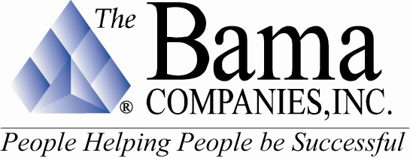
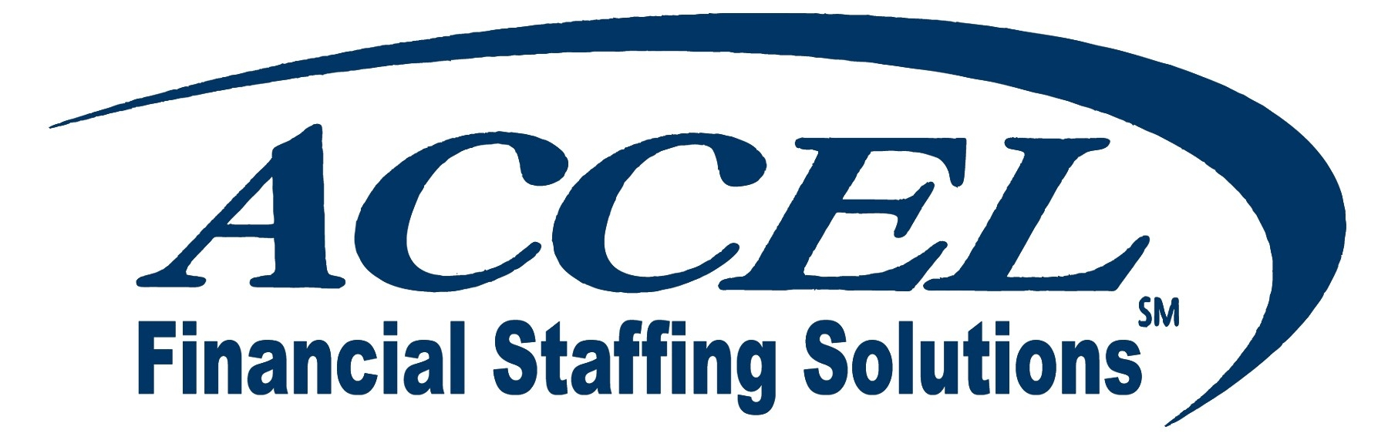





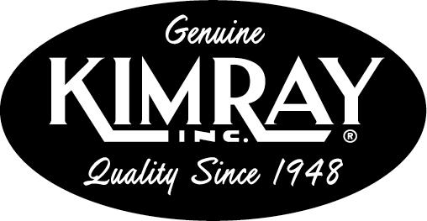

Sustaining Members:

Bill Bleakley, OKCBusiness
Roger Hicks, Hicks & Associates
Stan Martin, HealthHistories, Inc.
Blaine Rider, Digital West
Shannon Warren, Warren Consulting LLC

Fellowship Members:

Jacque | Bergman | Kerr-McGee,
Lynnda | Berryhill | Berryhill Insurance Agency. Inc.
Myrna S. | Latham | McAfee & Taft
Mary | Melon | The Journal Record
David | Rhoades | Fraud & Forensic Investigations
Shannon | Warren | Warren Consulting LLC
Debie | Weaver | The Fountains at Canterbury

Corporate Members:

Beale Professional Services
Boeing Company, The
Cole & Reed
CoorsTek
Coppermark Bank
Cox Communications - Oklahoma
Edward Jones (OKC)
Edward Jones Investments (Tulsa)
Enterprise Rent-A-Car
Epworth Villa Life Care Community
EWF International
Foundation Surgery Affiliates. Inc.
Gooden Group. Inc., The
Gray & Company. P.C. CPAs
Hogan & Slovacek
Holy Trinity Charismatic Episcopal Church
Langston University/Oklahoma City
Leader Communications. Inc.
Lisle Compton Cole & Almen LLP
Moore Norman Technology Center
Oneok. Inc.
Sharron’s Designs
Staffmark
State Chamber of Oklahoma
Third Degree Advertising
University of Central Oklahoma
University of Oklahoma
College of Arts and Sciences
University of Tulsa. The
Valir Health
Williams Companies
Woodrum Kemendo & Cuite

We are in the process of renewing memberships and were unable to list individual members at this time. If you do not see your name on this list and have already renewed or joined at the Corporate level and above, please notify Shannon Warren at (405) 858-2233 as soon as possible so that we may make corrections. Thank you for your patience!

TO JOIN THE OKLAHOMA BUSINESS ETHICS CONSORTIUM,
VISIT OUR WEBSITE AT HTTP://WWW.OKETHICS.ORG

