Oklahoma Business Ethics Consortium
June 14, 2006 ~ 11:30 to 1:00
Agenda

I. WELCOME & KUDOS Shannon Warren, Founding Director
  - Ron Hulsizer, IMA President for collaboration on this event
  - Connie Barwick, Maximum Multi-Media Creations (PowerPoint)
  - Vertina Long, Langston Scholarship Recipient

***OKETHICS COMPASS AWARD RECIPIENTS***
Congratulations to Eide Bailly & Valir Health – OkEthics FIRST Compass Award Recipients!
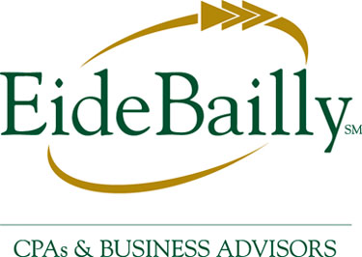


- S.O.S. ~ TREASURER NEEDED!
OkEthics Board of Directors is searching for a CPA and leader with integrity to serve in the capacity of Treasurer for our new fiscal year beginning October, 2006. To ensure a smooth transition, it will be necessary to identify someone to begin an orientation process before the new fiscal year. If you are interested in serving as a volunteer to promote Oklahoma values in the workplace, please call 858-2233 ASAP.
NOTE: Members of the Oklahoma Business Ethics Consortium frequently share information concerning various issues and developments that may have legal implications. The discussions, commentary, and handouts at Consortium meetings or presentations to other organizations are for general informational purposes only. They cover only some aspects of the subject topic, and do not constitute a complete legal analysis of the topic or how it might apply to any particular set of facts. Before taking any action based on information presented by a Consortium member, participants are encouraged to consult a qualified attorney. The observations and comments of presenters at Consortium meetings and networking are the views and opinions of the presenter and do not constitute the opinion or policies of the Consortium or any of its members.

III. OKETHICS RETREAT – Leadership & Committee members needed to help keep up the momentum!

IV. UPCOMING CONSORTIUM EVENTS

OKC Chapter
July 12 – Peter Dobelbower, General Counsel,
Hobby Lobby Inc. “The Human Touch”

Moore-Norman Chapter:
June 21 - Nathan Whatley of McAfee & Taft;
Corporate Responsibility
Tulsa Chapter:
June 22 – SpiritBank CEO Kell Kelly
July 27 – TU Coach Kragthorpe

Other Programs Related to Ethics
Character First – Business Leaders Breakfast/Luncheon
RSVP: 815-0001 or visit the Character Council Website at http://www.characterok.org/

VI. ROUND TABLE DISCUSSIONS Noon

VII. ADJOURN 1:00

****CPE CERTIFICATES WILL BE AVAILABLE FROM IMA****
PLEASE PICK ONE UP AS YOU EXIT THE MEETING TODAY
PLEASE HELP US CONTROL COSTS – LEAVE YOUR NAME TAGS WITH US!

