Oklahoma Business Ethics Consortium
November 9, 2005 ~ 11:30 to 1:00
Agenda

I. Welcome & Announcements 11:40
- Bob Byrne, Boeing
OkEthics Foundation, President

Congratulations UCO!
President Joe Walker & Advisor Dr. Katherene Terrell for record attendance of 150 participants at UCO Student Ethics event!

Student & Hosts Initiative
- DVD Presentation prepared by Digital West
- Support our student chapters
- Help with other initiatives – see flier!

II. Upcoming Consortium Meetings 11:50
- Shannon Warren,
OkEthics, Founding Director

OKC Chapter
December 14 meeting – NOTE LOCATION CHANGE TO THE MONTGOMERY!
***One CPE & CLE Ethics Credit***

January 11 – Tom Hill, COO of Kimray,
“Character Initiatives”
MOORE-NORMAN CHAPTER MEETING:
Members in OKC chapter may participate in other Chapter activities at the regular member rate. To make reservations, visit our website at www.okethics.org

November 16 – Character First! Program on CULTURE
What the studies show (see Journal Record column on survey):
- FORMAL PROGRAMS ARE NOT AS EFFECTIVE AS ESTABLSIHING A STRONG CULTURE
- ETHICAL BREACHES STILL OCCUR
- BARELY HALF OF EMPLOYEES WILLING TO REPORT PROBLEMS!

TULSA CONSORTIUM MEETINGS:
Members in OKC chapter may participate in other Chapter activities at the regular member rate. To make reservations, visit our website at www.okethics.org

November 10 -
“Ethical Dilemmas: Life or Death Decisions That Impact You and Your Business”
Presented by: Dr. Nancy Van Winkle, Behavioral Sciences, OSU Health Sciences
Dr. JoAnn Ryan, Interim Medical Director, OSU Clinic System

Other Programs Related to Ethics
Character First – Business Leaders Breakfast/Luncheon
Topic: “Self-Control in the Workplace”
Dates & Times: Tuesday, November 15, 7:00 a.m. – 8:00 a.m.
~or~Thursday, November 17, Noon – 1:00 p.m.
Location: Character First Institute, 520 West Main Street
Cost: Complimentary
RSVP: 815-0001 or visit the Character Council Website at http://www.characterok.org/

IV. KUDOS & HONORS 11:55
- Shannon Warren, Warren Consulting LLC
OkEthics Founding Director
& Valerie Fried, Capitol Abstract & Title Company
OkEthics Vice President, Public Relations

Character Awards:

Previous Character Award Recipients include:

TOM HILL, Kimray Manufacturing
REBECCA ADAMS, Oklahoma Ethics Commission
SHERE ROCKWELL, University of Tulsa Student
DR. DAVID CARMICHAEL, Oklahoma City University
STAN MARTIN, HealthHistories
MARY MELON, The Journal Record

Alan Muehlenweg
Director of Market
Research
Third Degree Advertising
Kari D. Snider
COO/Chairman of
the Board
Cicero International Advertising

Justin Trent Meek
President/CEO
Cicero International Advertising

Blaine Rider
Co-Owner
Digital West

V. Introduction of Speaker 12:25
- Janice Dobbs, Devon Energy
OkEthics Foundation Board Member

VI. Keynote Speaker: Lieutenant Governor Mary Fallin

VII. Adjourn 1:00

PLEASE HELP US CONTROL COSTS –
LEAVE YOUR NAME TAGS WITH US!

NOTE: Members of the Oklahoma Business Ethics Consortium frequently share information concerning various issues and developments that may have legal implications. The discussions, commentary, and handouts at Consortium meetings or presentations to other organizations are for general informational purposes only. They cover only some aspects of the subject topic, and do not constitute a complete legal analysis of the topic or how it might apply to any particular set of facts. Before taking any action based on information presented by a Consortium member, participants are encouraged to consult a qualified attorney. The observations and comments of presenters at Consortium meetings and networking are the views and opinions of the presenter and do not constitute the opinion or policies of the Consortium or any of its members.

OK-ETHICS MEMBERS: THANK YOU FOR LIGHTING THE WAY!

OKLAHOMA STARS



leading members
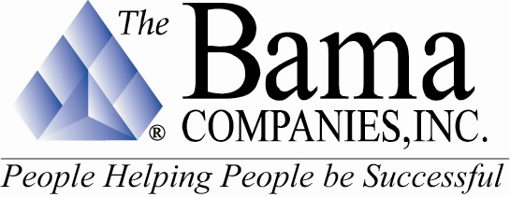
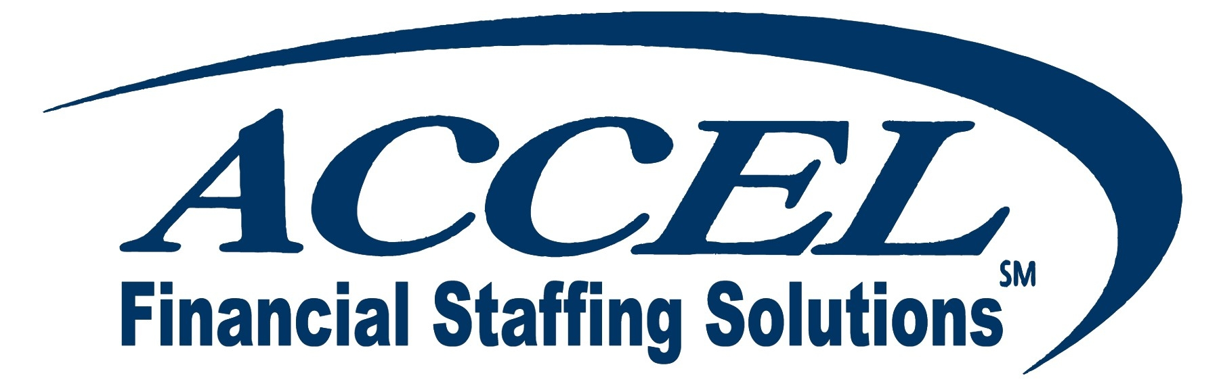




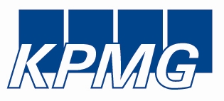

Sustaining Members:

Bill Bleakley, OKCBusiness
Roger Hicks, Hicks & Associates
Stan Martin, HealthHistories, Inc.
Blaine Rider, Digital West
Shannon Warren, Warren Consulting LLC

Fellowship Members:

Jacque | Bergman, | Kerr-McGee,
Lynnda | Berryhill, | Berryhill Insurance Agency. Inc.
Myrna S. | Latham, | McAfee & Taft
Mary | Melon, | The Journal Record
Gina | Miller, | Bama Companies. Inc.
C. David | Rhoades, | Fraud & Forensic Investigations
Shannon | Warren, | Warren Consulting LLC
Debie | Weaver, | The Fountains at Canterbury

Corporate Members:

Beale Professional Services
Boeing Company, The
Cole & Reed
CoorsTek
Coppermark Bank
Cox Communications - Oklahoma
Edward Jones
Edward Jones Investments
Enterprise Rent-A-Car
Epworth Villa Life Care Community
EWF International
Foundation Surgery Affiliates. Inc.
Gooden Group. Inc., The
Gray & Company. P.C. CPAs
Hogan & Slovacek
Holy Trinity Charismatic Episcopal Church
Langston University/Oklahoma City
Leader Communications. Inc.
Lisle Compton Cole & Almen LLP
Moore Norman Technology Center
Oneok. Inc.
Sharron’s Designs
State Chamber of Oklahoma
Third Degree Advertising
University of Central Oklahoma
University of Oklahoma
College of Arts and Sciences
University of Tulsa. The
Valir Health
Williams Companies
Woodrum Kemendo & Cuite

We are in the process of renewing memberships and were unable to list individual members at this time. If you do not see your name on this list and have already renewed or joined at the Corporate level and above, please notify Shannon Warren at (405) 858-2233 as soon as possible so that we may make corrections. Thank you for your patience!

