Oklahoma Business Ethics Consortium
September 13, 2006 ~ 11:30 to 1:00
Agenda

I. WELCOME & KUDOS Shannon Warren, Founding Director
  - Connie Barwick – Maximum Multi Media Creations for the pre-meeting Power Point presentations
  - The Accel Financial Staffing Team for their efforts in ensuring a smooth registration process
  - Bekah Mercer of Cicero International Advertising for ad design – during crunch times!
  - Blaine Rider of Digital West for Board Photos (appearing soon on ballots and website)
  - Alan Muehlenweg of Third Degree Advertising for Board ballot composition

***OKETHICS COMPASS AWARD RECIPIENTS***
Congratulations to Eide Bailly & Valir Health – OkEthics FIRST Compass Award Recipients!
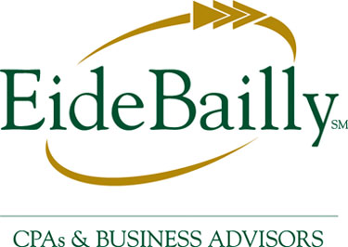
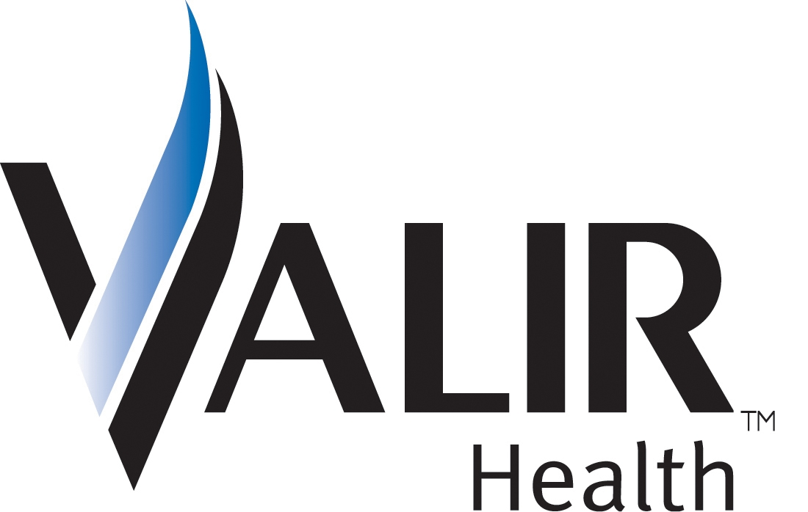

II. BOARD BALLOTS – Watch your email to vote for your slate of officers soon!
III. MEMBERSHIP DRIVE – JOIN/RENEW NOW!!!!!!!! Shannon Hiebert, President-Elect

- Drawing for door prize – Lies! Lies! Lies! Book to be signed by Dr. Ford next month.
Next drawing will made from the FIRST 50 to register for the October program – must be present to win!

- Kudos to Principal Technologies for the FIRST STAR MEMBERSHIP OF 2006-07!!!!
Oklahoma Stars = $5000 (Prepaid Events for 8, including Awards Banquet)
Individual Membership Levels: Corporate or Group Membership Levels:
⁮ Scout (formerly “Individual”) = $50 ⁮ Frontier (formerly “Corporate”) = $300
⁮ Trail Blazer (formerly “Fellowship”) = $500 ⁮ Leading (Same) = $1200
⁮ Navigator (formerly “Sustaining”) = $750 ⁮NEW Horizon (Prepaid group rates) = $2500
- GET INVOLVED!
The Membership and Public Relations Committees work together to help OkEthics flourish across the state. To do this important work, they need enthusiastic volunteers. If you are interested in serving as a volunteer to promote Oklahoma values in the workplace, please call Valerie Fried, VP of Public Relations at ValerieF@CapitolAbstract.com or 810-2457 or Shannon Hiebert at 330-9191.
REGISTRATION HELP NEEDED! Help with the transition process to a new registration team. More volunteers are needed who can provide a consistent and reliable presence at the meetings. Call Shannon Warren at 858-2233.

- UPCOMING CONSORTIUM EVENTS – Advance reservations required for all events.
NOTE: Members of the Oklahoma Business Ethics Consortium frequently share information concerning various issues and developments that may have legal implications. The discussions, commentary, and handouts at Consortium meetings or presentations to other organizations are for general informational purposes only. They cover only some aspects of the subject topic, and do not constitute a complete legal analysis of the topic or how it might apply to any particular set of facts. Before taking any action based on information presented by a Consortium member, participants are encouraged to consult a qualified attorney. The observations and comments of presenters at Consortium meetings and networking are the views and opinions of the presenter and do not constitute the opinion or policies of the Consortium or any of its members.
__________________________________________
YOU MAY REGISTER FOR ANY UPCOMING PROGRAMS THROUGH OUR WEBSITE AT www.okethics.org OR CALL 858-2233.

Moore-Norman Chapter

September 20 – Lance Benham
CEO & President, The Benham Companies

OKC Chapter

October 11 – “Lies! Lies! Lies”
Presented by Dr. Charles Ford,
noted author & psychiatrist
**CPE Credit**
November 8 – “Character & Integrity”
Presented by OCU’s Business Dean,
Dr. Vince Orza
**CPE Credit””

December 13 – “Strong Character Guides Professional Conduct”
***CLE CREDIT***

A study of the Character behind the Oklahoma Rules of Professional Conduct
Co-Sponsored by the Character Council of Central Oklahoma
Presented by Jack Gilchrist, Debee Gilchrist Law Firm

Tulsa Chapter

September 28 – Chris Wilson, CEO, Wilson Research Strategies
“Reputation & The Bottom Line”

October 26 – Jeff Mulder, Director, Tulsa Airport Authority

November 16 – Steve Turnbo, Chair, Tulsa Metro Chamber of Commerce
December 13 – Joint meeting with Tulsa Chapter of CPA’s, Internal Auditors and IMA

January 25 – Rick Wagner, Partner-in-charge, Eide Bailly

VI. Other Programs Related to Ethics
Character First – Business Leaders Breakfast/Luncheon
“Loyalty in the Workplace”
Tuesday, September 26: 7:00 a.m. – 8:00 a.m.
Thursday, September 28: Noon – 1:00 p.m.
RSVP: 815-0001 or visit the Character Council Website at http://www.characterok.org/

International Character Cities Conference – September 21 & 22; Call 815-0001 for details
Date: | Wednesday, September 20, 2006
Place: | Nonna's Painted Door, Bricktown
Time: | 11:30 a.m. to 1 p.m.
Cost: | $20 for PRSA Members  $30 for non-PRSA Members  $15 for PRSSA Students  $20 for non-PRSSA Students  Reservations:  president.elect@prsaokc.com  405-235-3313
“How to Erode Your Reputation”
An examination of ethics (and lack thereof) in public relations practice

VII. Nancy Coggins, President- Elect,
Public Relations Society of America
Media Survey Results

Keynote: NEWS 9’S ALEX CAMERON & ANGELA BUCKELEW 12:15

MODERATOR: PHIL BUSEY, CEO OF THE BUSEY GROUP
“Ethics in the Media”

IX. ADJOURN 1:00

PLEASE HELP US CONTROL COSTS – LEAVE YOUR NAME TAG WITH US!

OKLAHOMA BUSINESS ETHICS
SLATE OF OFFICERS
All positions are voluntary, non-compensated seats. Members will receive an email soon and are encouraged to vote for approval of the slate of officers by Wednesday, September 20.
NOTE: Currently, the VP of Membership position remains open with no nominees suggested at this time. It is expected that the gap will be temporarily filled by former VP, Shannon Hiebert.
President - Shannon Hiebert
Enterprise Rent-A-Car (Oklahoma City)
A Founding Member of OkEthics beginning in 2003, Shannon has served as Vice President of Membership for the Consortium since her appointment to the Board in 2004. She is Group Human Resources Manager for
Enterprise Rent-A-Car in Oklahoma City. Beginning in September, 2006, Shannon will be expected to fill a two-year term, one as President and the other as At-Large.
FOUNDING DIRECTOR - SHANNON WARREN
WARREN CONSULTING LLC (Oklahoma City)
Since the group's inception in October, 2003, Shannon has served as the Director on a non-compensated voluntary basis. To ensure continuity, she serves in this capacity on both the Consortium and Foundation Boards. This position serves at the pleasure of the Board and no term limits have been established.
PRESIDENT (Foundation) & VP OF EDUCATION & MENTORING (Consortium) - BOB BYRNE
BOEING (Oklahoma City)
Bob wears two hats - one as President of the Foundation, the 501c3 organization that supports university efforts and student chapters. He simultaneously acts as a VP on the Consortium Board to ensure continuity of communication between the two groups. Bob was appointed to the Board in January, 2005, subsequent to Harry Whitney's resignation to relocate out of state. Bob is the Ethics Advisor for Boeing Bob was appointed to a two-year term, with the option for continuance after January 2007 at his and the Board's mutual consent. This vote will extend his position through January, 2008.
PRESIDENT (Tulsa Chapter) - GENE BISHOP
Northpoint Wealth Management, LLC (Tulsa)
An experienced financial advisor, Gene was appointed to the Board in the capacity of VP, Development in December, 2005. The VP of Development position was dissolved in July, 2006, - at which time, the Board elected Gene to the position of President-Elect for the Tulsa Chapter. As such, he will be expected to serve two years - one as President and one as an At-Large member of the Tulsa Board.
PRESIDENT (Moore-Norman Chapter) - BUCK IRWIN
Nextep (Norman)
In July, 2006, Buck became one of the newest nominees to the Board. He is Chief Operating Officer for Nextep, a Norman-based consulting firm that was recently awarded the honor of "Best Places to Work" As President of the Norman chapter, he serves as a voting member of the Consortium and will be responsible for Chapter growth. Term will expire in July, 2007, unless renewed by a nomination or Board vote.
GENERAL COUNSEL(Consortium) - MYRNA SCHACK LATHAM
McAfee & Taft Law Firm (Oklahoma City)
A "go to" person in the arena of legal ethics, Myrna was appointed to the Consortium Board in April, 2005, She has played a crucial role in establishing both the Consortium and Foundation as non-profit organizations. A term limit has not
been established for this position.
GENERAL COUNSEL (Foundation) -H. CRAIG PITTS
Rubenstein, Bryan, McCormick & Pitts PLLC (Oklahoma City)
Craig is a CPA & experienced attorney who was appointed to serve the
Foundation Board in February, 2006. Craig has been invited to serve a one-year term, with the option for continuance after February 2007 at his and the Board's mutual consent

SECRETARY (Consortium) - ROB MARTINEK
The Bama Companies (Tulsa)
Rob is Director of Legal Services and Finance for The Bama Companies, the only Oklahoma company to receive a national Malcolm Baldridge Award. He was appointed to the position in September, 2005. Rob was invited to remain in his current capacity on the Board through the new fiscal year of 2006-07.
TREASURER (Consortium & Foundation) - DAVID MAYFIELD
Eide Bailly LLP (Oklahoma City)
David, a CPA, a native of Oklahoma City, has served as a senior manager at Eide Bailly, LLP, since 2000. He heads the audit department in Oklahoma City and is expected to help OkEthics implement procedures in accordance with the non-profit Standards of Excellence. David will be the newest appointee, effectively assuming his duties for a one year term in September, 2006.
VICE PRESIDENT, PUBLIC RELATIONS - VALERIE FRIED
CAPITOL ABSTRACT (Oklahoma City)
Valerie is Executive Vice President - Finance/Human Resources Director for Capitol Abstract & Title Company. She is a Founding Member of OkEthics and has served as Chair of the Public Relations Committee for the past two years, before being appointed to the Consortium Board as Vice President in March, 2006. A term limit has not been established for this position.
AT-LARGE MEMBER (Foundation) - JANICE DOBBS
Devon Energy (Oklahoma City)
Janice has served as a voting member on the Foundation Board since May, 2005. She was instrumental in helping us launch the Oklahoma Executives for Business Ethics initiative. A term limit has not been established for this position.
AT-LARGE MEMBER (Consortium) - LYNN FLINN
EWF International (Tulsa)
Lynn has served in the capacity of President since the Tulsa inception of OkEthics in April, 2004. She was instrumental in establishing the Tulsa chapter and will be providing continuity as a voting member of the Board for the next year,
through September 30, 2007.

