

“WHEN FAITH
and WORK
VALUES COLLIDE”

November 4, 2009
Oklahoma Sports Hall of Fame & Jim Thorpe Museum
Oklahoma City, Oklahoma

Religion’s Impact on Ethical
Decision-Making in the Workplace
A Panel Discussion
Most of us are taught to live out our faith perspectives and not to shelve these values when we go to work. But what happens when our personal principles collide with the demands at work? How does that impact our ability to collaborate with one another to resolve ethical dilemmas in the workplace? This program is intended to help individuals bridge that gap by facilitating a greater understanding of the ethical principles employed by various religious perspectives in guiding individual behavior.

General Disclaimer: Members of the Oklahoma Business Ethics Consortium frequently share information concerning various issues and developments that may have legal implications. The discussions, commentary, and handouts at Consortium meetings or presentations to other organizations are for general informational purposes only. They cover only some aspects of the subject topic, and do not constitute a complete legal analysis of the topic or how it might apply to any particular set of facts. Before taking any action based on information presented during a Consortium event, participants are encouraged to consult a qualified attorney.

The observations and comments of presenters at Consortium meetings and networking are the views and opinions of the presenter and do not constitute the opinion or policies of the Consortium or any of its members. Presenters are respectfully requested to avoid profanity, preaching, politics and self-promotion during their lectures.

CPE CERTIFICATES
It is the responsibility of participants to demonstrate applicability of each program for demonstration of earned CPE credits, to his/her area of practice. OK Ethics makes no guarantees. Also, attendees must be present to accept CPE certificate at the conclusion of the program.

CPE CERTIFICATES WILL BE ISSUED AT THE BACK OF THE ROOM ON
BEHALF OF NASBA AT THE CONCLUSION OF THIS EVENT
NOTE THAT WE WILL NOT EMAIL THESE

YOU MUST BE REGISTERED ON THE OKETHICS’ ATTENDANCE LIST TO
RECEIVE A CERTIFICATE

MEET THE PANELISTS:

I. OPENING REMARKS:   | Dr. Imad Enchassi  President & Imam  Islamic Society of Greater OKC
  Born in a refugee (Sabra & Shatila) camp in Lebanon from a Palestinian father (of Egyptian roots) and Syrian mother, Dr. Enchassi witnessed the Lebanese civil war, the invasion of Lebanon, and the massacre of the refugee camps of 1983. He migrated to the USA at age 17 where he attended Texas Weslyan College (Ft. Worth, TX), Weatherford College, Texas Tech University , Southern Nazarene University and University of Phoenix. He earned undergraduate and graduate degrees in management, Human Resources and leadership.
II. OVERVIEW OF FAITHS:     | Andrew Tevington  "Our Faiths" columnist for The Oklahoman  and author of the book, "Our Faiths: A Peace Offering" | The Rev. Andrew Tevington is author of "Our Faiths," a newspaper column devoted to explaining the practices of various religions in America and around the world. He also wrote Our Faiths: A Peace Offering, which expands the column's look at the world's religions. In the early 1990's, the Rev. Tevington served on the Oklahoma Constitution Study Commission and wrote the constitutional amendment eventually passed by voters to create the Oklahoma Ethics Commission, the first constitutional body of its kind in the United States. The Commission regulates the ethical behavior of state government officials. The Rev. Tevington is a licensed attorney, having practiced as an assistant district attorney in the Oklahoma County District Attorney's office, assistant attorney general in the Oklahoma Attorney General's office, general counsel to Gov. Henry Bellmon, and various other public and private capacities. He was graduated from the University of Oklahoma College of Law. He is licensed to preach in the United Methodist Church and serves as pastor to the Chapel Community at the Church of the Servant in Oklahoma City. He received a master of divinity degree magna cum laude from Phillips Theological Seminary. His original degree, in journalism and broadcasting, was earned at Oklahoma State University.
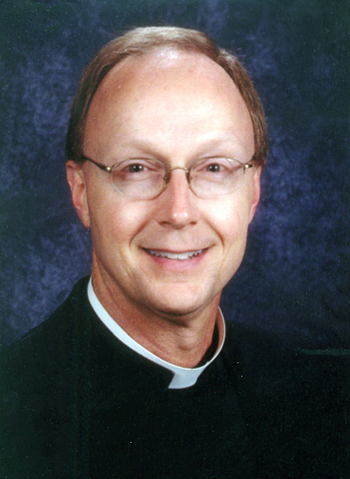III. CATHOLIC PERSPECTIVE: | Father Rick Stansberry  Pastor  Christ the King Catholic Church | Born in Oklahoma City, Father Stansberry attended Casady School and graduated in 1979. He then attended SMU in Dallas before obtaining an MBA at OCU. After that, he worked as an accountant for three years before attending Seminary at St. Meinrad Seminary in Indiana. There, he received an M.Div and a M.A. in Religious Studies. His career began as associate pastor at St. Charles Borromeo in Oklahoma City for 5 years after ordination. This was followed by attendance at the Angelicum University in Rome for a degree in Canon Law. Since that time, he has worked in the Archdiocese Marriage Tribunal and was pastor of St. Peter and Paul in Kingfisher OK. Later, he served as pastor at St. Francis parish in Oklahoma City for five years and is currently pastor of Christ the King. In addition to this, Father Stansberry serves as the Judicial Vicar for the Archdiocese of Oklahoma City, putting him in charge of the marriage tribunal.
IV. BUDDHIST PERSPECTIVES:  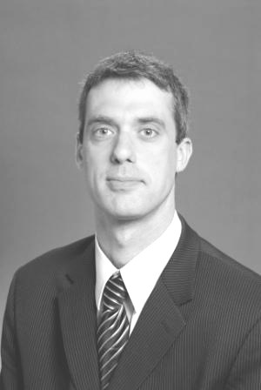 | John Cougher  Director of Development  Jeannine Rainbolt College of Education,  University of Oklahoma | John Cougher has been practicing Zen Buddhism since 1999 and spent six years living and training at residential Zen facilities in Los Angeles, California and Providence, Rhode Island, part of that time as a postulant monk. He became an ordained as a lay Dharma Teacher in the Kwan Um School of Zen in 2005. He lives with his wife and two children in Norman and works in the Development office at the University of Oklahoma.
V. MEDITATION  for relieving workplace tension & conflict  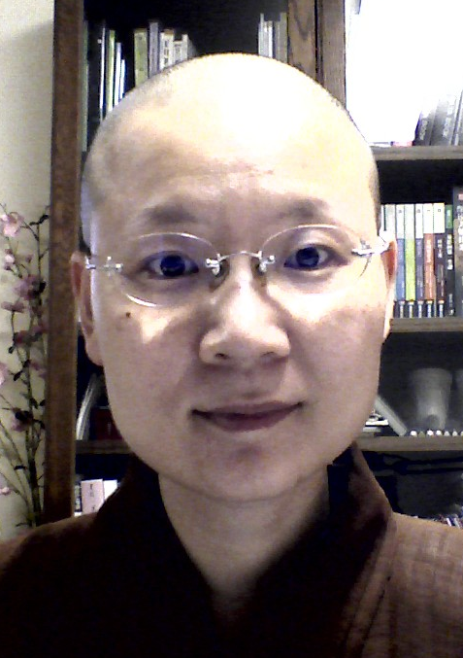 | Venerable Jian-Mao  Abbess  Buddha Mind  Monastery | Venerable Jian-Mao graduated from National Central University, Taiwan, with a bachelor degree in physics and a master degree in Economic Development and further attained a doctorate degree in Religious Studies majoring in Chinese Buddhism from Sichuan University, China. She was ordained under Venerable Master Wei Cheuh in 1996 at Chung Tai Chan Monastery in Taiwan. She has been serving as the abbess of Buddha Mind Monastery, a U.S. branch of Chung Tai in Oklahoma City, since 2007. With many years of religious training in Zen Buddhism and deep understanding of Chinese Buddhism and other various religious fields, she is uniquely suited to bring the ancient yet timeless wisdom of Buddhism to America’s melting pot of cultures.

When Religion and Business Collide:
Can We Be Ethical?
By Andrew Tevington, J.D., M.Div.

Every religion—including each which professes atheism—espouses a code of ethics. While the details of these codes may differ, the underlying concept is the same from faith to faith to non-faith. We call this core belief the Ethic of Reciprocity.

The founder of the Baha’i faith expressed it as, “O son of being! Ascribe not to any soul that which thou wouldst not have ascribed to thee, and say not which thou doest not. Hidden Words of Baha’u’llah, No. 29.

Hinduism, perhaps the oldest continuously practiced faith tradition, says, “This is the sum of duty: Do naught unto others which would you pain if done to you.” Mahabharata, 5:1517.

Judaism, in contention with Hinduism for the title of oldest current religion, says, “[L]ove your neighbor as yourself.” Leviticus 19:18.

Taoism calls on all moral individuals to “[r]egard your neighbor’s gain as your own gain, and your neighbor’s loss as your own loss.” T’ai Shang Kan Yin P’ien, 213-218.

In Islam, the ethic is taught as, “None of you believes until he wishes for his brother what he wishes for himself.” An-Nawawi’s Forty Hadiths, No. 13.

For the Buddhist, it is known as ahimsa and states simply, “Hurt not others in ways that you yourself would find hurtful.” Udana-Varga, 5:18.

The Jain, who does not see a god in the cosmos, teaches, “A man should wander about treating all creatures as he himself would be treated.” Sutrakritanga 1.11.33.

Likewise, Anton LaVey, founder of modern Satanism wrote, “Satanists must strive to apply the dictum of ‘Do unto others as they do unto you.’ It’s work for most of us and requires constant vigilance. “The Nine Satanic Sins,” No. 3.

And of course, that statement is based on what Christians know as the Golden Rule from the Sermon on the Mount: “[D]o to others what you would have them do to you.” Matthew 7:12.

This ethic is developed in various ways. In Hinduism, we find the Five Principles and Ten Disciplines, which urge ahimsa also known as non-violence, truthfulness, celibacy, cleanliness and other concepts highly valued in the West as well as the East. In Judaism and Christianity, the Ten Commandments extend the basic concept of reciprocity. Christianity also uses the teachings of Jesus, especially from the Sermon on the Mount as found in the fifth chapter of the Gospel of Matthew. Muslims accept the Torah and Gospels, as they believe these writings are overseen by the Qu’ran; therefore, the ethics of the Ten Commandments and the Sermon on the Mount are recognized. At least 17 Quranic verses give direct voice to the various teachings more familiar to Americans from Hebrew and Christian Scriptures. Buddhists employ the Noble Eight-fold Path, which tells believers how to behave correctly, through such things as right occupation, right action, and right speech.

In the practice of all these faiths and non-faiths, people find great difficulty in matching their beliefs to their everyday lives—including their lives at work. This is to be expected as each system calls its followers to be better in the future than they are in the present. Improvement of our ethical performance requires as much stretching and hard work as needed to strengthen our bodies or lengthen our endurance for physical performance. It may entail as many years of study and practice as our formal educations involved, as we improved our minds’ performance.

For basically decent people, the ethical problem arises most often when we are required to do something distasteful, such as raising prices, firing employees, or suing a supplier. Most often the conflict between our beliefs and such actions arises because we think of ethical behavior in too small an environment. We consider, for example, only the person in front of us if we are involved in an employee termination. How can we hurt this individual and his or her family in a time of recession? How can we wound his or her self image? How can we be so mean?

The ethical issue is not always about the person in front of us. If we do not take this action, how have we harmed all other employees who have contributed mightily to the company? If we do not act, how do we affect productivity and eventually our ability to remain in business so that the vast majority of good employees may retain their jobs? If we do not act, how do we affect our fiduciary duty to our shareholders, who often rely on dividend income to live in their senior years? Where is the hurt? Where is the greater harm?

When we seek to treat others as we want to be treated, are we limited to just one person at a time or to whole groups or to both? Can we be true to our beliefs and to our correct work responsibilities by insisting on proper performance by an individual for the benefit of multitudes? Can we help the individual so we may eventually improve the lot of the multitudes by dealing with problems before they become so big that they are irreparable? Wouldn’t we want to be treated in a way that lets us know our performance is subpar and helps us to improve so we don’t face termination?

Acting rather than avoiding is the key to ethical behavior. Helping rather than hiding is the way to follow the Golden Rule.


A Catholic Perspective on Making Ethical Decisions
By Father Rick Stansberry

First of all one must look at the morality of the human act. Which involves three elements:
- The object chosen
- The end or the intention
- The circumstances of the action

We also believe that God created us as free human beings, however all of our actions have consequences and for a good decision to be reached we must look at the action and always remember as St Thomas says, “ The end does not always justify the means.”

When making ethical decisions, the teachings of Christ , Ten Commandments and the Word of God should be considered as well, i.e. “ Thou shalt not bear false witness, or Thou shalt not covet thy neighbors goods.” For example if a person is called up on to lie for their boss, and not lying could cause them to fired. One would need to look at what was being lied about and what is the greater good. Another example would be that if one was coveting thy neighbors job and went to great extents to discredit them, that would be wrong.

Another area that needs to looked at are the circumstances of the act. They can increase or decrease the morality of the act and increase or decrease the person’s responsibility. For example acting out of fear of death. A soldier who is fighting a just war, may have to take the life of another person in the line of battle, that is far different than killing innocent civilians.

There are some acts that are always illicit, such as blasphemy, perjury, murder or adultery, the Catechism of the Church #1756, states that one may not do one of these evil acts so that good may result from it.

Formation of Conscience

The duty of the Catholic person is to have a well formed conscience, so that they can make good ethical decisions. The definition of Conscience is that “ In all that we say and do humanity is obliged to follow faithfully what they know to be right and just.” CCC 1778. To follow what is good and right and just one must have a well formed conscience.

For example life is precious and must always be protected in all ethical decisions. If a Catholic were asked to help with an abortion for example, he or she would be held responsible for that act even though they may not have actually performed the abortion.

Conscience is formed primarily through the Word of God and the Teachings of Jesus and the Church, there are some rules however that apply in all cases:
- One may never do evil, so that good may result in it.
- The Golden rule applies, “ Do unto others as you would have them do unto you.”

Charity always proceeds an action to respect another person and their conscience, “ Sinning against your brother and wounding their conscience.. you sin against Christ.(1 Corinthians 8:12)

Another criteria to be used in ethical decisions are the Corporal Works of Mercy:
- feed the hungry
- shelter the homeless
- clothe the naked
- visit the sick
- visit the prisoner
- bury the dead

Above all in all ethical decisions, one must use wise and prudent judgment, which is one of the gifts of the Holy Spirit, and in all things remember “ What would Jesus do?”

The Ten Commandments
1. Thou shalt have no other gods before me.

2. Thou shalt not make unto thee any graven image, or any likeness of any thing that is in heaven above, or that is in the earth beneath, or that is in the water under the earth: Thou shalt not bow down thyself to them, nor serve them: for I the LORD thy God am a jealous God, visiting the iniquity of the fathers upon the children unto the third and fourth generation of them that hate me; And shewing mercy unto thousands of them that love me, and keep my commandments.

3. Thou shalt not take the name of the LORD thy God in vain; for the LORD will not hold him guiltless that taketh his name in vain.

4. Remember the sabbath day, to keep it holy. Six days shalt thou labour, and do all thy work: But the seventh day is the sabbath of the LORD thy God: in it thou shalt not do any work, thou, nor thy son, nor thy daughter, thy manservant, nor thy maidservant, nor thy cattle, nor thy stranger that is within thy gates: For in six days the LORD made heaven and earth, the sea, and all that in them is, and rested the seventh day: wherefore the LORD blessed the sabbath day, and hallowed it.


5. Honour thy father and thy mother: that thy days may be long upon the land which the LORD thy God giveth thee.

6. Thou shalt not kill.

7. Thou shalt not commit adultery.

8. Thou shalt not steal.

9. Thou shalt not bear false witness against thy neighbour.

10. Thou shalt not covet thy neighbour's house, thou shalt not covet thy neighbour's wife, nor his manservant, nor his maidservant, nor his ox, nor his ass, nor any thing that is thy neighbour's.
The Five Precepts of Buddhism
Provided by John Cougher

The Buddha taught us that we already have a balanced nature. We are, each one of us, already perfect and complete. As we endeavor to wake up to the compassionate and wise state, we must see what hinders us.

The instructions are so simple: Avoid evil and do good. Why can’t we just write that in large letters over our beds and make sure we read it before we put our feet on the floor each morning? Then, as Zen Master Seung Sahn says, “just do it”? Avoid evil and do good, moment to moment to moment.

The precepts spell out the major hindrances. It’s so obvious what these hindrances are and so helpful to be reminded of them. Read them and be honest with yourself; ask yourself to deepen your understanding of what it means to not take what is not given. What does it mean when it says to always tell the truth? Did we “kill” anything today? Were we destructive? How intimately familiar can we become with the precepts so that we can put our feet on the floor in the morning and not have to think of dichotomies such as good and evil? The precepts become, “How may I help you?”

As our practice matures, as we shed our accumulated fears and mistrust, we do realize that being compassionately awake is our natural state. We can take the sign off our bedroom wall and give it to a brother or sister who might still need the reminder.

As members of our Zen Center and of our larger sangha, we recognize and support each others’ efforts. When we make our direction and vow clear together, we not only help each other, we also inspire our extended community around the world.

Barbara Rhodes (Zen Master Soeng Hyang)
School Zen Master

Below are the Five Precepts given by the Buddha to his lay disciples. They are still taken today by lay Buddhists around the world. These precepts can be interpreted quite literally, but also can be viewed in a deeper context. Beneath each of the Five Precepts are some examples of how some Buddhists might approach them as ethical guidelines at work.

I vow to abstain from taking life.
Are we in a sense “taking life” when we de-humanize, objectify or belittle others? How about taking away others’ dignity?
I vow to abstain from taking things not given.
How does this apply to illegally downloading file-sharing programs/music/videos? Spending company time on outside work or the internet?
I vow to abstain from misconduct done in lust.
Indulging in fantasy about or flirting with a co-worker; having an affair with a coworker; These usually don’t lead to a positive outcome.
I vow to abstain from lying.
In what other ways do I stretch the truth that may be just short of “lying”? Taking undeserved credit for projects or achievements? Promising more to a boss, co-worker or client than I am able to achieve?
I vow to abstain from intoxicants, taken to induce heedlessness.
Power, pride, etc. can be intoxicants; my tendency to drink too much coffee in the morning makes me less mindful

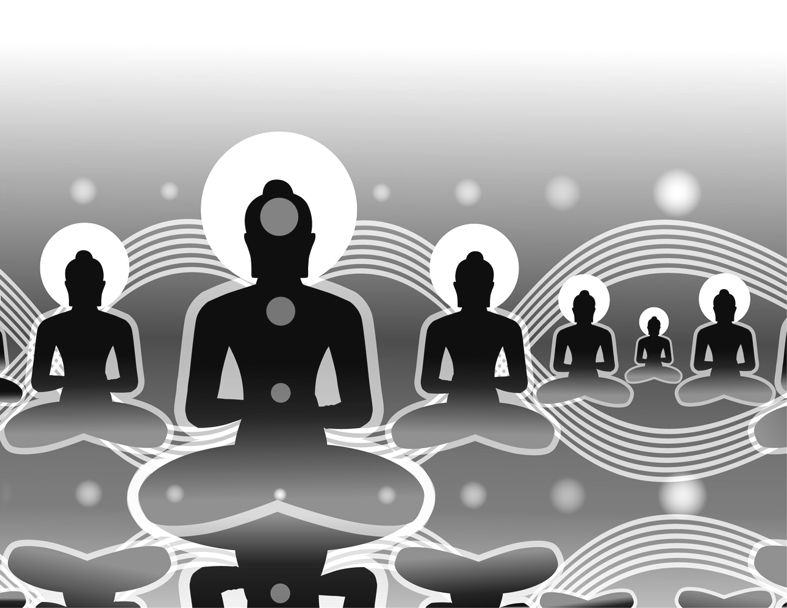


Eightfold Path –
The Buddha’s summary guideline to
mental and ethical development
Provided by John Cougher

Research has shown that repeated action, learning and memory can actually change the nervous system physically, altering both synaptic strength and connections. Such changes may be brought about by cultivated change in emotion and action; they will, in turn, change subsequent experience.” – Gay Watson

Related to Wisdom
- Right View
- Right Intention

Related to Ethical Conduct
- Right Speech – How a Buddhist practitioner makes best us of their words.
“And what is right speech? Abstaining from lying, from divisive speech, and from idle chatter: This is called right speech.”
- Right Action – Not acting in ways that would be corrupt or bring harm to oneself or to others.
“And what is right action? Abstaining from taking life, from stealing, and from sexual misconduct: This is called right action.”
- Right Livelihood – Buddhists ought not to engage in trades or occupations which, either directly or indirectly, result in harm for other living beings (from Wikipedia).
According to the Buddha, the five types of businesses that are harmful are:
- Business in weapons: trading in all kinds of weapons and instruments for killing.
- Business in human beings: slave trading, prostitution, buying or selling of children or adults
- Business in meat: “meat” refers to the bodies of beings after they are killed. This includes breeding animals for slaughter.
- Business in intoxicants: manufacturing or selling intoxicating drinks or addictive drugs.
- Business in poison: producing or trading in any kind or toxic product designed to kill.

Related to Concentration
- Right Effort
- Right Mindfulness
- Right Concentration

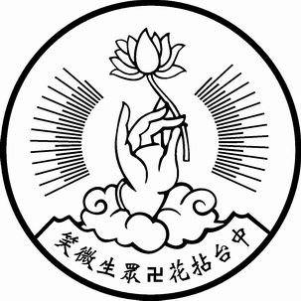
Introduction to Zen Buddhism
Provided by Venerable Jian-Mao, Abbess. Buddha Mind Monastery

Chung Tai Chan Monastery

“Wonder of wonders! All sentient beings are inherently complete and perfect.”

Buddha, Dharma, and Sangha
The word buddha is a Sanskrit word which means “The Awakened One”, one who is awakened to Reality, to the true nature of the mind; one who knows the world and all sentient beings without delusion, one who is perfect in wisdom and compassion. Other common epithets of the Buddha are: tathagata (Thus Come One), or bhagavat (World-Honored One).
The Buddha lived approximately 3000 years ago (some say 2500). He was an Indian prince named Siddhārtha, who gave up his throne in order to search for the Truth, to find a way to bring relief to the sufferings of humanity. After many years of diligent practice, he reached Supreme Enlightenment while sitting under a bodhi tree. He then exclaimed, “Wonder of wonders! All sentient beings are inherently complete and perfect! But they do not realize it because of their delusions and cravings.” Thereupon he was known as Śākyamuni (or Gautama) Buddha, and embarked on an untiring journey to teach living beings how to see Reality, how to gain true wisdom, and how to free themselves and attain true peace and joy. His teaching is known as the Dharma. The Buddha taught for 49 years until he entered nirvana at the age of 80.
Many disciples followed the Buddha’s example; they renounced the home life to devote their lives to the practice of Enlightenment, and to teach other sentient beings the same. They formed the ordained community of Buddhist monks and nuns known as the Sangha. Sangha means “harmony” or “harmonious assembly”. The Sangha is responsible for preserving and propagating the Buddha Dharma. Buddha, Dharma, and Sangha are called the Three Jewels, the true treasures of the world.

Buddhist Ideal
Buddhists believe that everyone can be awakened, that everyone can become a Buddha. To be awakened means to see reality as it is, not as we think it is. To see reality is to gain true wisdom and this wisdom will free us. We are not trapped by external conditions, but by our misperceptions and prejudices. Whatever we do, our actions create reactions that come back to affect us. Because of this, we are responsible for our own actions. Also because of this, we are responsible for our own salvation. Each one of us is capable of achieving perfection. We just need to know how. The Dharma teaches us how. There are many ways of practice, many “Dharma gates” to achieve enlightenment, and they all fall into these general categories: performing good deeds, meditation, and studying the Dharma.

Zen Buddhism
There are many Schools of Buddhism. They differ not in the final objective of reaching Buddhahood, but in their different emphasis on methods of practice.
A particularly important and influential school is Zen (also called Chan/Ch’an in Chinese). Zen’s origin goes back to the Buddha. One day, an assembly gathered to hear the Buddha’s Dharma talk. However, on that day, instead of speaking, the Buddha simply held up a flower in front of the assembly in silence. No one understood the meaning except one disciple, Mahākāśyapa, who broke into a smile. Thereupon the Buddha said, “I have the supreme teaching, inexpressible by words and speech; it is the true Eye of the Dharma, the profound Mind of Nirvana, the Reality transcending all forms—I now trasmit to Mahākāśyapa.” Thus was the first transmission of the “mind-seal”, and Mahākāśyapa became known as the first Patriarch of Zen.
The Zen lineage continued in India until the time when the 28th Patriarch, Bodhidharma, sailed to China and passed on the teaching. Bodhidharma became known as the first Patriarch of Chinese Zen. Thereafter Zen flourished in China, especially after the great Sixth Patriarch, Huineng. Throughout Chinese history there were many enlightened masters, as well as notable Korean, Japanese, and Vietnamese masters. Today, all forms of Chan or Zen practice trace their root to Bodhidharma and Huineng.
What is Zen? Practically, we may say that it is a state of mind, a mind of calmness, stability, and clarity; a mind free of delusions and confusions; a mind in accord with true Reality. It is not a dull mind, but one full of infinite potentials. Such a mind is the source of wisdom; it is a state of true liberation and joy.
To achieve the Zen state of mind, proper meditation practice is very important. Meditation helps us to focus, calm down, become aware, and begin to see things as they are. A properly trained mind is one ready for awakening.

Basic Etiquettes and Terminology

Shifu/Dharma Master: The proper way to address a Buddhist monk or nun. Shifu means “Dharma Master” or “Dharma Teacher”. For example, you may address the abbot as “Dharma Master Jian-Hu”, “Jian-Hu Shifu”, or simply, “Shifu”. In letter, we are addressed sometimes as “Ven.” which means “Venerable.”

Palms together: most common way of greeting among Buddhists or in a monastery. With fingers together and upright, join the palms in front of one’s chest.

Half bow: more respectful way of greeting, to the Buddha or Shifu or to each other. With palms together, lower the upper body 90 degrees and rise again.

Full bow/prostration: most respectful greeting, to the Buddha or Shifu. One kneels down, with hands, knees and forehead touching the ground. Prostration is performed to show utmost respect and to help rid of one’s arrogance.

Note: Buddhist monks and nuns are celibate, and avoid bodily contact in general (especially with the opposite sex). So instead of shaking hands, joining palms is the proper greeting.

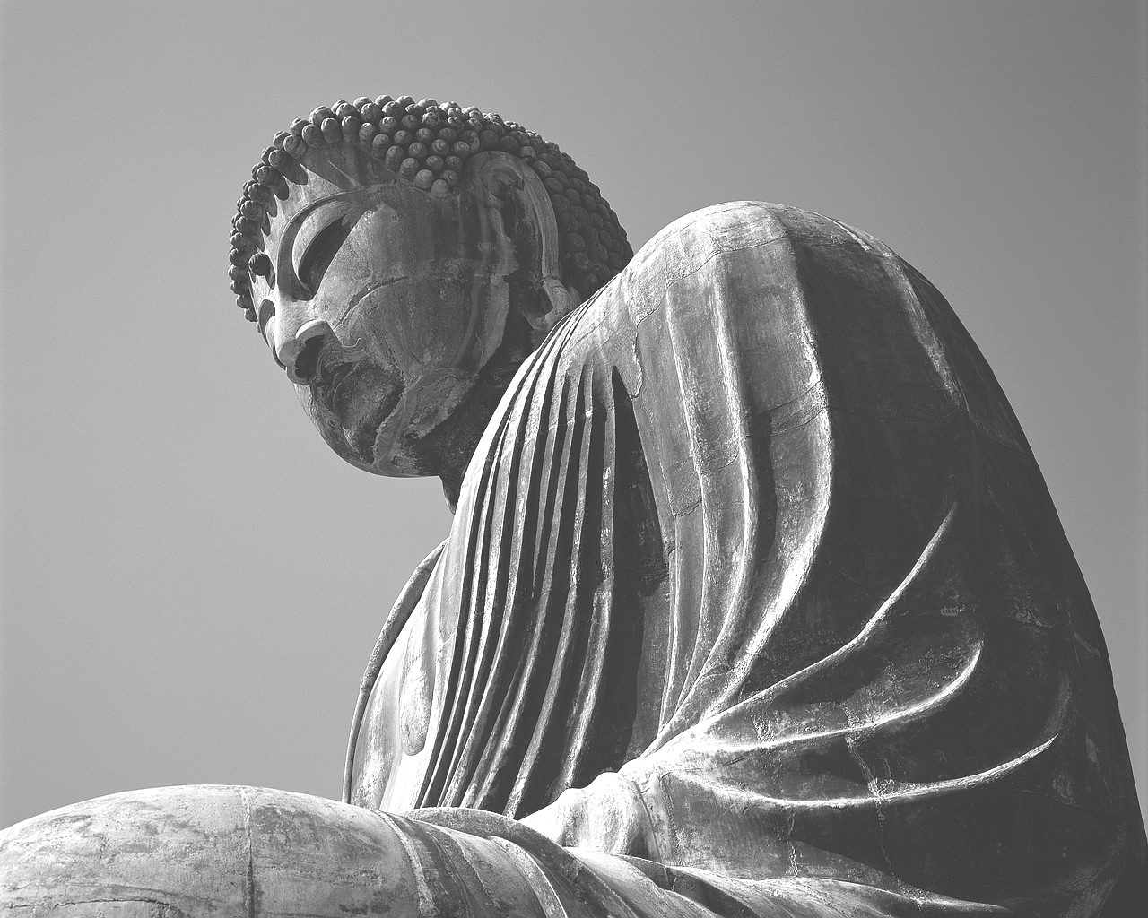
2. Buddha

Buddha discarded all beliefs and speculations that could not be proven in
actual experiences.

When Siddhārtha Gautama (Gotama in Pali) was born to King Śuddhodana and Queen Maya of the Śākya clan, the future Buddha walked seven steps immediately and declared, “I am the most venerated of all that exist in heavens and on earth.” Siddhārtha means “able to accomplish all.”
As Prince Siddhārtha grew up in the protected and luxurious surroundings of the palace, and mastered the traditional philosophy and arts of India, he was not content with his life. Outside the palace, he saw the old, the sick, and the dead; he saw the sufferings of the common people. He quickly realized that duhkha (suffering, dissatisfaction) were common to all people, and that this was a most important issue concerning all sentient beings. Yet, it seemed that most people either are numb to it or tried to ignore it. He wished to find out the fundamental cause of human suffering. He wished to bring emancipation to all sentient beings.
One night, Siddhārtha decided to leave the palace and everything behind to become a mendicant monk in search of Truth. He practiced with the best gurus and learned how to achieve the deepest meditative states. However, true knowledge still eluded him. He went on to lead the life of an ascetic, as was popular in India at the time, for six years, eventually realizing that neither hedonism nor asceticism led to enlightenment. He did not give up; instead, he turned to the wisdom within, meditated on the Middle Way and penetrated the illusive nature of all duality.
He sat under a bodhi tree for 49 days, and finally reached perfect enlightenment. He saw that what prevented us from seeing the Truth and attaining liberation was because of the “three poisons”: greed, anger, and ignorance. By eradicating the three poisons, we can get rid of the root of all delusions and suffering.
From then on, he was known as the Buddha, “the Awakened One,” or Śākyamuni, “the Sage of Śākya clan.” (Or Gotama Buddha in Theravada Buddhism.) He began “turning the Dharma Wheel”, and taught mankind the paths to attain liberation such as the Four Noble Truths, the Eightfold Path, the Principle of Causality, Dependent Origination, Emptiness, the Six Paramitas (Six perfections), and the Middle Way.
The Buddha taught for 49 years, always at peace, patient, wise, and never emotional; indeed, he lived up to his teachings to perfection. He entered nirvana at the age of 80. His chief disciples, such as Venerables Mahākāśyapa and Ānanda, collected the Buddha’s verbal teachings for future generations. These Buddhist scriptures are known as sūtras. The entire collection of the Buddhist canon is known as the Tripitaka.
The Buddha’s teaching is similar to science in that it is knowledge gained from the examination of reality. Buddha discarded all beliefs and speculations that could not be proven with actual experiences. However, it differs from the physical sciences in that the key to true understanding begins by examination inward, into our own minds. As all phenomena are perceived by the mind, if the mind is not first trained to be focused, unbiased, and clear, it will not perceive truthfully. This is why even scientific discoveries can be mistaken. This is why meditation practice is crucial to achieving enlightenment.

In the Buddha Hall
Śākyamuni Buddha: The statue in the middle of the altar.
Bodhisattva Guan Yin and Bodhisattva Earth Treasure: Bodhisattva of Compassion, and Bodhisattva of Great Vow. (Bodhisattva: enlightened beings on the way to Buddhahood.)
Mahākāśyapa and Ānanda: The two smaller statues on each side of the Buddha. They are two of the Buddha’s chief disciples. They are also the first and second Zen Patriarchs of India.
Dharma instruments: the daqing (big gong大罄), muyu (wooden fish木魚), and yinqing (hand-bell引罄). They are used in Buddhist services.
Small Buddha Lamps: offering of light (lamp) for wisdom and blessing is a Buddhist tradition.
Meditation stools, mats, and blankets.
Xiangban (Awakening Staff香板): to keep the meditator’s mind alert, and for adjusting postures.
“Namo Buddha”: How Buddhists greet each other verbally. In Chinese it is “A mi to fo.”

Chan Buddhism I

3. Meditation
All pure wisdom arises from meditation.
The purpose of meditation is to calm, to purify and to clarify the Mind. When the Mind is still and clear, without thoughts, sleepiness, or feeling of boredom, one become holy.
Ordinary beings have more unwholesome thoughts than wholesome thoughts. Negative thoughts, such as greed, anger, ignorance, arrogance, jealousy, hatred and miserliness, cause one to experience vexations, loneliness, horror, etc. and to kill, to steal, to rape and to commit other evil deeds. The world is thus in disorder, and the bad effects of suffering eventually revert back to the doer.
Wholesome thoughts, on the other hand, bring the good effects of abundance and happiness. As it is said:”Heaven blesses those who have good thoughts.” In the cultivation of Buddhism, the goal is to reach”No thought when in meditation, and only good thoughts when in activity.”

Adjusting the body
During meditation, it is best to sit in full lotus position, which requires crossing the legs and resting both feet on top of the thighs. Why do we sit in the full lotus position? Because that is the position in which the body is totally centered.That is also the position one can sit comfortably the longest period of time and let you easily to enter into deep meditation. Maybe you don’t believe that, because it hurts. If you keep on practicing, your legs will be flexible. Then you may understand why the full lotus position is the best.
If too strenuous, one can attempt the half lotus position, which consists in resting one foot on top of the thigh. If this is still too difficult, simply crossing the legs will suffice. The shoulders should be relaxed and the hands should form the Diamond Mudra, in which one hand is on top of the other with the tip of the two thumbs touching each other.（Diamond fist Mudra—bottom of the left thumb cover the bottom of the right thumb, the rest of the four fingers of the right hand wrap both thumbs and the other four fingers of the left hand cover the right hand.）The hands should rest on the feet close to the abdomen.
The body should also be relaxed, but not stiff and the back should be straight. The chin should be pulled inward, and the head should be upright with the back of the neck slightly touching the collar. The tongue should remain behind the front teeth, against the roof of the mouth. The eyes should remain slightly open, and the eyelids should be lowered naturally. One tends to be distracted when the eyes are open and to fall asleep when the eyes are closed. When there is neither distraction nor sleepiness, the eyes can be opened or closed as one wishes. A faint smile on the face helps one to relax.

For health reasons, it is advisable to start meditation forty minutes after a meal.
During meditation, the pores of the whole body will open and measures should be taken to protect it, particularly the knees and the neck. The knees should be covered with a blanket to prevent cold air from entering the joints, in order to avoid health problems. The back of the neck should be covered for the same reason. In addition, one must not sit too close to a slightly opened window as a cold wind may blow on the neck and also cause health problems.
Adjusting the breath
To meditate better, the breath should be smooth and soundless. At the outset, one should take three deep breaths, inhale through the nose and exhale through the mouth. The meditator should breathe in and out as slowly as possible. Air should be taken in all the way down to the lower abdomen and let out slowly through the mouth until it is exhausted. This should be repeated 3 times. Then one continues breathing in and out natually and through the nose only. Breathing through the mouth is not healthy.
Breath Counting Method
Finally, it is time to adjust the Mind. One should count from 1 to 10 silently when exhaling but not when inhaling. Or, one can count when inhaling and not count when exhaling. One should not count on both inhalation and exhalation as it can be detrimental to one’s health. The reason for breath counting is to use the ten numbers to substitute for the 840 million thoughts humans have every day. One should remain focused on the counting and not be distracted. When the Mind wanders off, one should immediately become aware of it and bring the Mind back to the counting. If too many thoughts distract the process of counting forward, one can count backward.
If the breath is too short to count up to 10, one can count to 7 or 5. Through practice, the capacity of the breath will increase, and one can count to 7 and eventually to 10. One should not exceed 10.Counting should be paced. Counting too rapidly does not serve to calm an overly active Mind, while counting too slowly may cause one to run out of breath.
The Breath Counting Method can be practices during sitting meditation or before retiring for the night. When in activity, it is not proper to practice this method.
Mindfulness of Breathing Method
After counting the breath for a time, the Mind becomes tranquil, and breathing becomes so subtle that it may even seem to cease. Counting is no longer necessary. One can then change to the Mindfulness of Breathing Method. Or, if counting the breath is difficult and cause headaches or gasping for breath, one can go directly to the Mindfulness of Breathing Method. This means that one no longer counts the numbers but just observes the breath. It is necessary to be constantly mindful that one is breathing in and breathing out.

Out of Meditation
One should come out of meditation gently. Lightly shake the shoulders and move the body. Do not let go of the legs too quickly as that may injure them. Slowly put the legs down. One should bend the body gradually and massage the thighs down to the feet while exhaling air through the mouth and inhaling through the nose three times. One should rub the hands and use them to rub the face, head, shoulders and body. It is advisable to stand up and take a walk, speeding up gradually in order to let out the air and energy so that they will not accumulate in the body and cause problems.

For more information on meditation, Venerable Jian-Mao recommends an online article that appeared in Time magazine in 2006: “How to Get Smarter, One Breath at a Time”
To access it go to http://psyphz.psych.wisc.edu/web/News/Time_Jan06.html

Tathagata means “acting in accordance with Truth”. It also means “neither coming nor going.”
Zen is derived from the Chinese “Chan”. From 9th century A.D. onward, many Korean and Japanese monks came to China to receive the Chan teaching. They went back and started their own lineages. Chan is called Zen in Japan. In the 20th century, several Japanese masters came to America to teach Zen, and therefore most Westerners know Zen but not its original name Chan.
The “I” does not refer to the ordinary self, but the original nature that everyone has, which is the most precious of all.
Nirvana means the extinction of all desires and karmic bondage. It is a state of absoluteness and liberation. When a sage enters nirvana, however, an ordinary being sees only the passing from the body which looks like death.
Tripitaka means the Three Baskets or Three Treasuries: the sutras (spoken by the Buddha), vinaya (precepts and moral codes), and sastras (treatises or commentaries on the Sutras by distinguished Buddhist disciples). Of the hundred-volume huge Tripitaka collection, only a small fraction of which has been translated into English.

