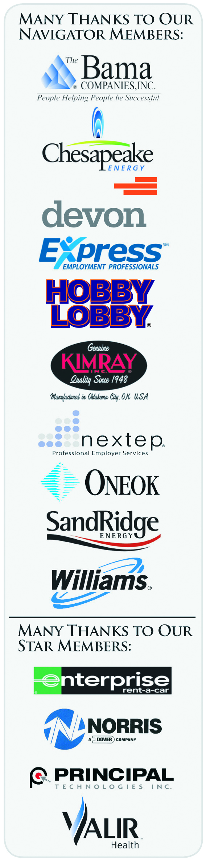
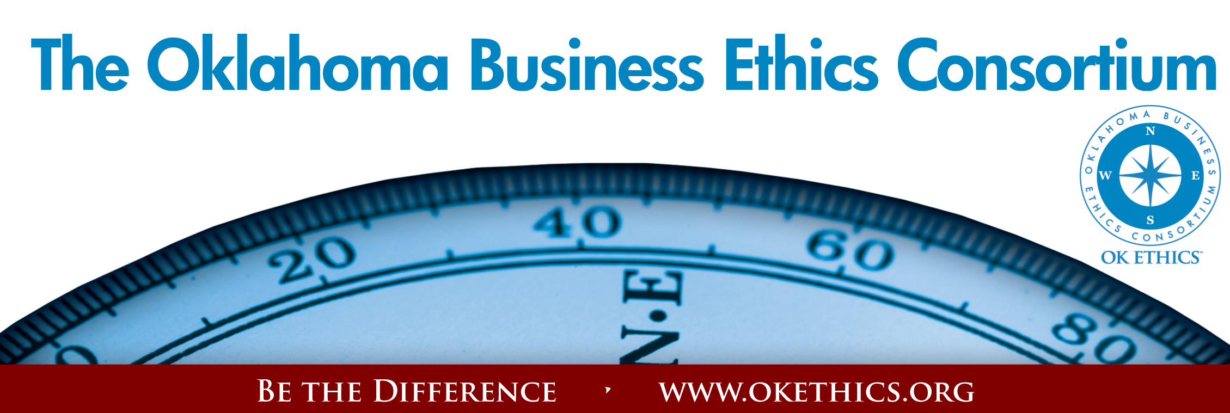
Oklahoma Business Ethics Consortium – August 25, 2009
Moore-Norman Chapter

I. Welcome & Kudos Garyl Geist, CEO, Valir Health;
President, OK Ethics Board of Directors
"Men of integrity, by their very existence, rekindle the belief that as a people we can live above the level of moral squalor. We need that belief; a cynical community is a corrupt community."
-- John W. Gardner
American writer and secretary of Health, Education and Welfare (1912-2002)
Volunteers:
- Linda Streun, Ideal Homes: - Agendas & Registration
- Kellian Schneider, Full Force Marketing & Branding –
Fliers for The Journal Record
Special thanks to Member Care Coordinator, Deborah Gavula

II. Early Bird Special - Deadline: August 28

Renew your membership at the Frontier level or above by August 28 and we’ll list your company as a flagship enterprise in a brochure that will be circulated statewide to 4800 subscribers via The Journal Record.
Upgrade or join now and get the September 2009 program included at no additional charge, e.g. eleven programs for the cost of ten!

- Do you know someone who has been laid off?
OK Ethics is offering a free SCOUT membership (value of $75) to any business professional who has been recently impacted by a reduction-in-force. See the website or call 858-2233 for more details.
WWW.OKETHICS.ORG

MANY THANKS TO THESE COMPANIES WHO HAVE ALREADY RENEWED FOR FY09-10!!!

Company | Level | Chapter
Chesapeake | Navigator | Okc
Devon Energy | Navigator | Okc
Hobby Lobby | Navigator | Okc
SandRidge Energy | Navigator | Okc
Helmerich & Payne, Inc. | Horizon | Tulsa
Hertz | Horizon | Okc
Metro Technology Centers | Horizon | Okc
Enterprise Rent-A-Car | Stars | Okc
Accel Financial Staffing | Leading | Okc
Accounting Principals | Leading | Tulsa
BKD, LLP | Leading | Okc
BancFirst | Leading | Okc
Cherokee Nation Enterprises | Leading | Tulsa
Citizen Potawatomi Nation | Leading | Okc
McAfee & Taft | Leading | Okc
PricewaterhouseCoopers LLP | Leading | Tulsa
Coherent Contracts, LLC | Trailblazer | Moore/Norman
Leader Communications, Inc. | Trailblazer | Okc
Principal Technologies | Trailblazer | Okc
Sonic Corporation | Trailblazer | Okc
Walker Companies | Trailblazer | Okc
Character Training Institute | Frontier | Okc
East Central University | Frontier | Okc
Grant Thornton LLP | Frontier | Okc
Ideal Homes of Norman, LP | Frontier | Okc
Maximum Multi Media Creations | Frontier | Okc
Tulsa Metro Chamber | Frontier | Tulsa
University of Tulsa | Frontier | Tulsa

IV. Introduction of Keynote Speaker
Dr. Tom Boyd, University of Oklahoma
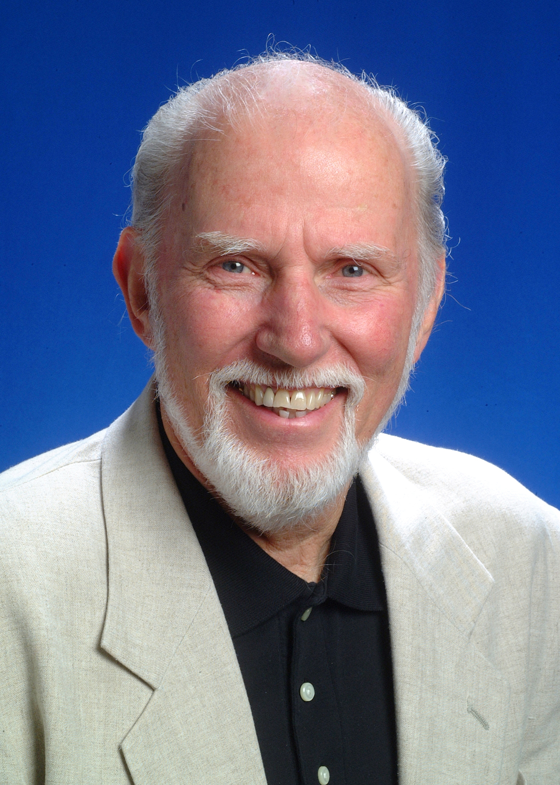
“Ethical Maturity”
As individuals, we are constantly striving to evolve. While there are programs delving into emotional intelligence, this program will provide insights on developing
ethical maturity: Doing the right thing for the right reasons.
Tom W. Boyd is the David Ross Boyd Professor Emeritus of Philosophy at the University of Oklahoma. After teaching philosophy of religion and ethics there for 28 years, he retired from fulltime teaching in 1997. He also retired from the ordained ministry in the Presbyterian Church USA in the summer of 1998.
Tom holds four earned degrees, including a Ph.D. in Religion from Vanderbilt University in 1973. His academic specialization is in philosophical theology, theories of religion, religion and culture, and ethics. His current concentration is on the relation among world religions and the relation between religion and culture. He also studies the impact of religion on ethics.

- UPComing Events: Bob Byrne, OK Ethics Foundation Board of Directors

MOORE-NORMAN CHAPTER PRESENTS:
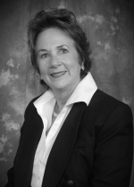
September 16
Carolyn Shockley,
Norman Regional Health Care Systems
“Technology & Ethics
in the Health Care Industry”

OKC CHAPTER PRESENTS:
Take the free online “Who Trusts You?” analysis offered by coveylink.com
Visit the okethics.org website for access
September 9  “The Speed of Trust”  Based on Stephen Covey’s latest book  Presented by  William J. Siems, Boeing  Certified Covey Trainer  Recommended for 1 CPE in Ethics | 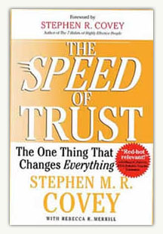

October 14 | November 4
John Richels  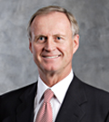 |     Religion’s Impact on Ethical Decision-Making in the Workplace
President, Devon Energy | Father Rick Stansberry;  Our Faiths Columnist,  Andrew Tevington

TULSA CHAPTER EVENTS:

August 27  Staying in the Black while Going Green: | September 24  “How to Develop Productive &  Loyal Employees”
The rewards for doing the right thing with our environment  A Panel Discussion   | 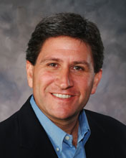  Chet Cadieux  Chief Executive Officer  QuikTrip

- Other upcoming programs of interest:

Character First Institute:
OK Ethics is honored by our friendship with the
Character First! Institute.
They provided wisdom and the basis for our Guiding Principles.
For more information on upcoming Business and Community Leaders' Luncheon, please contact them at 815-0001, or visit www.characterok.org./
Cost is $10 per person. The next topic is
“Responsibility” to be presented on
Thursday, August 27

General Disclaimer: Members of the Oklahoma Business Ethics Consortium frequently share information concerning various issues and developments that may have legal implications. The discussions, commentary, and handouts at Consortium meetings or presentations to other organizations are for general informational purposes only. They cover only some aspects of the subject topic, and do not constitute a complete legal analysis of the topic or how it might apply to any particular set of facts. Before taking any action based on information presented during a Consortium event, participants are encouraged to consult a qualified attorney.

The observations and comments of presenters at Consortium meetings and networking are the views and opinions of the presenter and do not constitute the opinion or policies of the Consortium or any of its members. Presenters are respectfully requested to avoid profanity, preaching, politics and self-promotion during their lectures.

