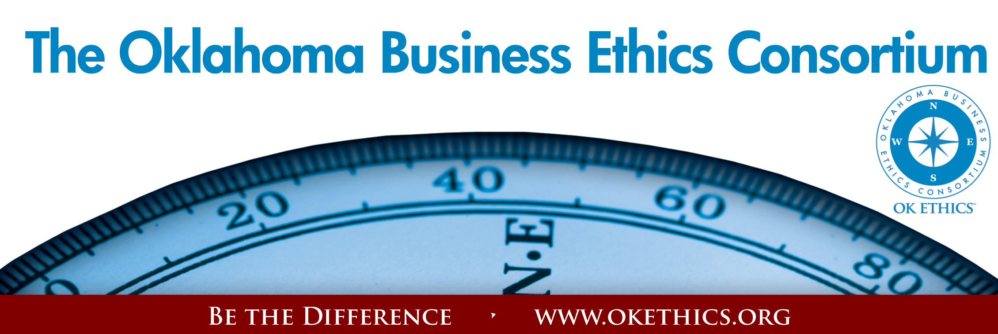
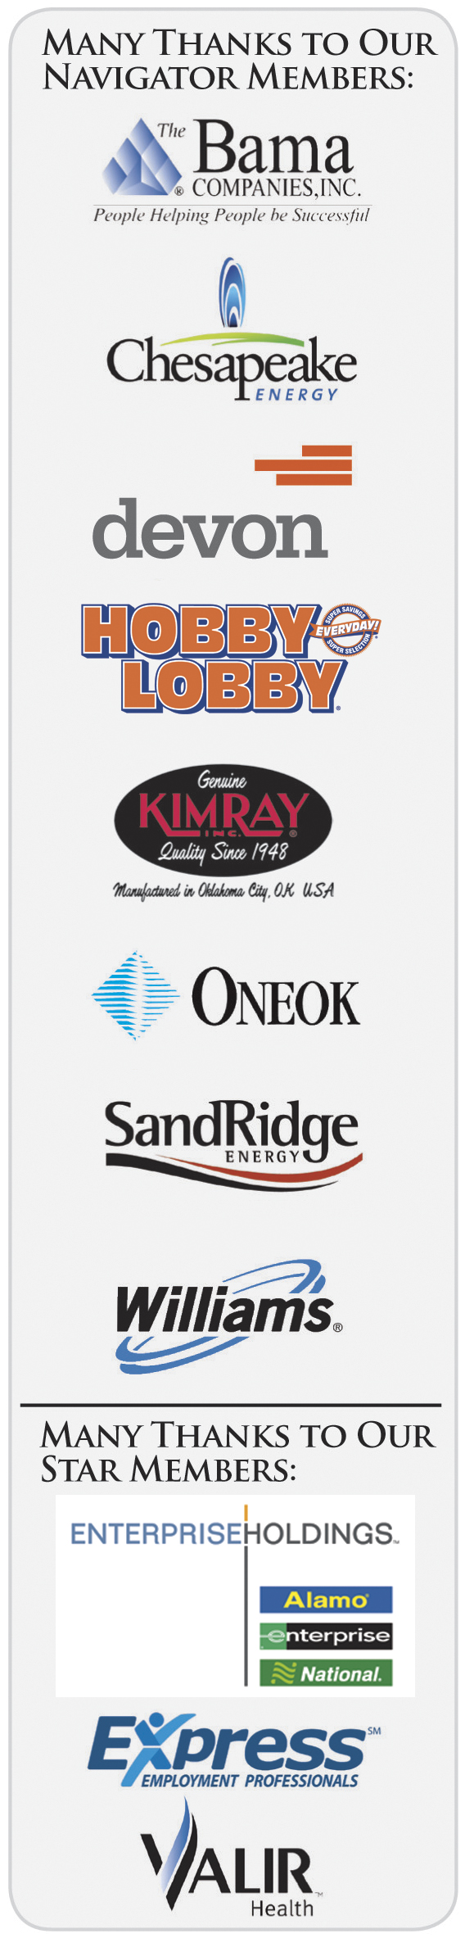
Agenda
January 13, 2010
I. Welcome Pam Fountain, President
OK Ethics Foundation Board
Principal Technologies, CEO
Welcome students and faculty!
- Langston University
- Oklahoma City University
- Rose State College
- Southern Nazarene University
- University of Central Oklahoma
- University of Oklahoma

II. SPECIAL KUDOS – VOLUNTEER RECOGNITION
“The Importance of Gratitude” - Gerald Coury, The Character Doctor
“No one who achieves success does so without acknowledging the help of others. The wise and confident acknowledge this help with gratitude.” ~Author Unknown
Board Appreciation: Shannon Warren, Founder, OK Ethics
(See attachment)
Foundation Volunteer Awards: Presented by Pam Fountain
- Breea Bacon – University of Oklahoma
- Dr. Barbara Crandall – Oklahoma City University
- Dr. Katherene Terrell – University of Central Oklahoma

Consortium Volunteer Awards: Presented by Garyl Geist,
President, OK Ethics Board of Directors
Power Point Presentations: Serving since December 14, 2005
Connie Storey - Maximum Multi Media Creations

Registration Team Leaders: Serving since October 11, 2006
Greg Byers, Registration Chair – Sinclair Broadcasting
Mary Kay Huggard, Registration Co-Chair – Principal Technologies

Chief Ambassador:
Tere Bettis - Coppermark Bank

Registration & Ambassador Team Members:
Becky Cavnar, OBU International Graduate School; Debbie Gardner & Renee Kissler, Accel Financial Staffing Specialists; Sherree Murray, SNU; Brent Martens, Beau Reed & Kimberly Nation, Accounting Principals; Mark Neumeister, D. R. Payne; Linda Streun, Ideal Homes, Mary Vaughn CPA; Joe Walker, Grant Thornton; Ashley Warne, Principal Technologies, Inc.

Agendas:
Bobby Redinger – Cole & Reed

Architects:
Tere Bettis, Lynda Mobley – ONEOK, Edith Steele
Banner:
Tess Smith – Walker Companies
CPE Certification:
Edith Steele, Colin Autin & Barbara Walker - Oklahoma Accountancy Board

Handouts:
Linda Manaugh – Metro Technology Centers

Name Tags:
Lisa Giles & Jamie Potter – Eide Bailly

Member Care Coordinator: Deborah Gavula

III. ANNUAL COMPASS AWARDS – COMING SOON!
Co-Chairs: Edith Steele, Oklahoma Accountancy Board
Mike Strong, Oklahoma Quality Award Foundation
Start early – download last year’s applications on our website at www.okethics.org ; Nominate a company that models Oklahoma standards of integrity at work.
IV. GUIDING PRINCIPAL Doyle Paden, Cherokee Nation Enterprises

V. NATIVE AMERICAN WISDOM
Dr. Jim Collard, Moderator,
Director of Planning and Economic Development
Citizen Potawatomi Nation
Director of Strategic Planning and Economic Development for the Citizen Potawatomi Nation and as a member of the Oklahoma Indian Affairs Commission Advisory Committee, Dr. Collard's background includes over 17 years in the city management profession and five years as an executive in the environmental services industry. As an economic developer, he chaired a regional Council of Governments and a County Economic Development Corporation and served on the Executive Committee of a separate County Economic Development Corporation with a population base of over 250,000. At the international level, Dr. Collard served on Governor Carnahan's (Missouri) International Advisory Committee and accompanied him on a trade mission to Asia, chaired the Lindenwood University Board of Overseers International Student Advisory Committee, and traveled extensively throughout the northern hemisphere on business and as part of two Citizen Ambassador delegations.
Dr. Collard holds a Ph.D. in Political Science from the University of Missouri St. Louis. His dissertation examined tribal-municipal cooperation in Oklahoma. His current research interest concentrates on the relationship between intergovernmental cooperation and regional economic indicators.

Barbara A. Warner, M.B.A.
Executive Director
Oklahoma Indian Affairs Commission
Barbara A. Warner, an enrolled member of the Ponca Nation of Oklahoma, is the first female Executive Director of the Oklahoma Indian Affairs Commission. She is a graduate of Putnam City High School in Oklahoma City and received a M.B.A. in Management and Bachelors degrees in Sociology and English from the University of Central Oklahoma.
Before assuming her position with the Commission in November 1993, Barbara's employment history included positions with state government, the private sector, tribal government, and Indian organizations, as well as several years with the American Indian Institute at the University of Oklahoma. As President of her own consulting firm, Roaring Thunder & Associates, she has provided consulting services to tribal housing authorities, primarily in the areas of needs assessment, program evaluation, grant writing, and substance abuse prevention.
Barbara represents the Commission on a number of boards including the Native American Cultural & Educational Authority as an ex officio; the Red Earth Board of Directors; the Oklahoma Capitol Complex Centennial Committee; the Oklahoma Native American Business Development Center Advisory Board; and the Oklahoma Native American Heritage Day Celebration Committee, among others. On a national level, she has served as the Year 2000 President of the Governors' Interstate Indian Council (GIIC), the national organization for state Indian affairs offices across the U.S., and was National Treasurer for GIIC in 1995 and 1996. She currently serves as a member of the GIIC Board of Directors.
In 1996, she was presented the American Indian Chamber of Commerce Leadership Award for outstanding leadership and advocacy and the Chamber's Advocate of the Year award in 1999. In 1997, she was selected as the Outstanding Indian of the Year by the American Indian Exposition and the Ponca Nation subsequently presented her with a personal and professional achievement plaque in recognition of her work and selection as Indian of the Year. She was the recipient of a Certificate of Recognition for Service to Native Americans of Oklahoma, which was presented by Mayor Susan Savage of Tulsa in 1998. In the annual reader poll for the Native American Times, Barbara was named as the Best of Indian Country Activist for Indian advocacy in 2000 and Best of Indian Country Leader (nonelected) in 2001. Barbara was presented with the Oklahoma Supreme Court 2001 Friend of the Court medal at Sovereignty Symposium XIV. In 2008, Barbara received a Governor's Commendation for outstanding service rendered during the Oklahoma's Centennial Celebration. Also in 2008, she received the Oklahoma State Service Award during the annual Native American Heritage Day Celebration at the State Capitol, as well as a Governor's Commendation for service.

Kirke Kickingbird
Of Counsel
Hobbs, Straus, Dean & Walker, LLP
Mr. Kickingbird is currently engaged in the private practice of law with the Washington, D.C. based firm of Hobbs, Straus, Dean and Walker in their Oklahoma City office. He was director of the Washington-based Institute for the Development of Indian Law for twelve years, General Counsel to the U.S. Congress' American Indian Policy Review Commission (1975-1977), Manager of the Native American Unit and Rocky Mountain Regional Office of the Legal Services Corporation (1987-88), and Director of the Native American Legal Resource Center at Oklahoma City University School of Law (1988 to 2000). He is admitted to the Oklahoma and District of Columbia bars. He consults on topics related to Indian law and tribal government including economic development, tribal constitutions, powers and governing codes, tribal courts, taxation, jurisdiction, treaty rights and environmental concerns.
Mr. Kickingbird graduated from the University of Oklahoma (B.A., 1966, J.D.,1969) and has practiced Indian Law since 1969. He is a member of the Kiowa Tribe and Kiowa Gourd Clan. He has written extensively on matters related to Indian law and tribal government. His latest publications are: Youth for Tribal Government (UNITY, Inc., Oklahoma City, 2001) and The Health of American Indians and Alaskan Natives, Chapter 4, "The Relation of Indian Nations to the U.S. Government," with Dr. Everett R. Rhoades (Johns Hopkins University Press, July, 2000), and Striving for the Independence of Native American Tribal Courts, which deals with the development of tribal courts under the Indian Tribal Justice Act of 2000 (Human Rights magazine of the American Bar Association, Winter 2009).
He has provided training and technical assistance to over 150 tribal governments in the United States and Canada, and has consulted with experts and governmental officials from Canada, Norway, Australia, New Zealand, Japan, South Africa, South America and Russia on indigenous people's rights. He has served on three U.S. delegations to United Nations conferences in Geneva dealing with the rights of indigenous peoples. He was named to International Who's Who in 1995.
Kickingbird is also a member of the Oklahoma Indian Bar Association, former President of the Native American Bar Association (2000-2001), and past board Chair of Oklahoma Indian Legal Services (1991-94). He served as Chairman of the Oklahoma Indian Affairs Commission during his term (1992-95) and also as Chief Justice of the Supreme Court of the Cheyenne and Arapaho Tribes of Oklahoma (1994-1995). He served as Special Counsel on Indian Affairs to the Governor of Oklahoma, Frank Keating (1995-2000). He was the first American Indian elected as one of the 37 members of the Board of Governors of the American Bar Association (1996-2000).

Jack Thorpe
Son of athlete Jim Thorpe
Executive Director
Sac and Fox Housing Authority
Mr. Thorpe is currently the Executive Director Sac and Fox Housing Authority. Jack has been in and around the Housing Program since 1971. He has been an Executive Director for twenty years, serving with Sac and.Fox Housing Authority, Kickapoo Housing Authority in Oklahoma and the Kickapoo Housing Authority in Kansas. Over the years Jack has been the President of the United Tribes of Oklahoma and Kansas, President of the United Indian Nations in Oklahoma, and Secretary of the National Tribal Chairmans Association.
Attended Grade School, Pawnee Indian School Pawnee Oklahoma.
Attended High School, Chemawa Indian School Salem Oregon
Attended Haskell Institute Lawrence Kansas
Attended University of Oklahoma Norman, Oklahoma (College of Continuing Education)
Served in the U.S. Army 1955 to 1958
Tribal Positions include Former Principal Chief, Sac & Fox Tribal Nation President of the United Tribes of Oklahoma and Kansas President of the United Indian Nations of Oklahoma, Secretary of the National Tribal Chairmen's Association
Jack wife Babs, two daughters and one son, five grand children live in Shawnee. They have lived at the same address for 36 years.

VI. UPCOMING EVENTS Shannon Warren, Founder
Oklahoma Business Ethics Consortium Board of Directors
January 25 - UCO Student Ethics Chapter Monthly Meeting
“Ethics - Chesapeake Style”
Discussion of the types of ethical issues dealt with and the tools developed for solutions.
Monday, January 25, 2010 - 2:30 p.m. (2:00 p.m. Social)
Troy Smith Lecture Hall, UCO College of Business, B113
Guest Speaker: Tony Blasier
Ethics Officer for Chesapeake Energy Corporation
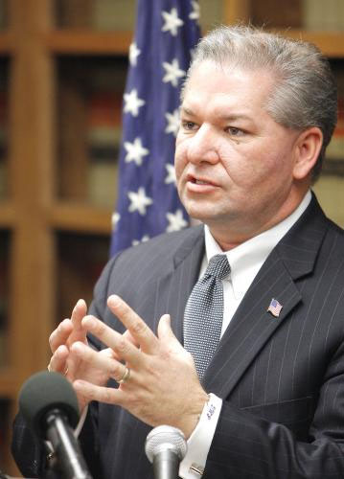
Please contact Dr. Katherene Terrell for parking pass at kterrell@uco.edu

February 13 – David Prater, Oklahoma District Attorney
Kudos to new OK Ethics Board member Tony Blasier of Chesapeake for making these arrangements.

Is Civility Lost?
If the cornerstone of ethical behavior involves respecting others, then it could be that
our society in general is slipping a bit. This program will offer some practical solutions
for restoring best behavior in our workplace and culture.
Recommended for 1 CPE in Ethics
Sorry Works!
March 10 – 11:30 to 1:00
Petroleum Club – Downtown OKC
Bad Manners = Bad Business | Just Say You’re Sorry…..
Carey Sue Vega, an award-winning etiquette  expert, is a director for the Oklahoma City Metropolitan  Chapters of The National League of Junior  Cotillions and The International League of  Corporate Cotillions, will discuss the importance  of etiquette in demonstrating respect for others. | 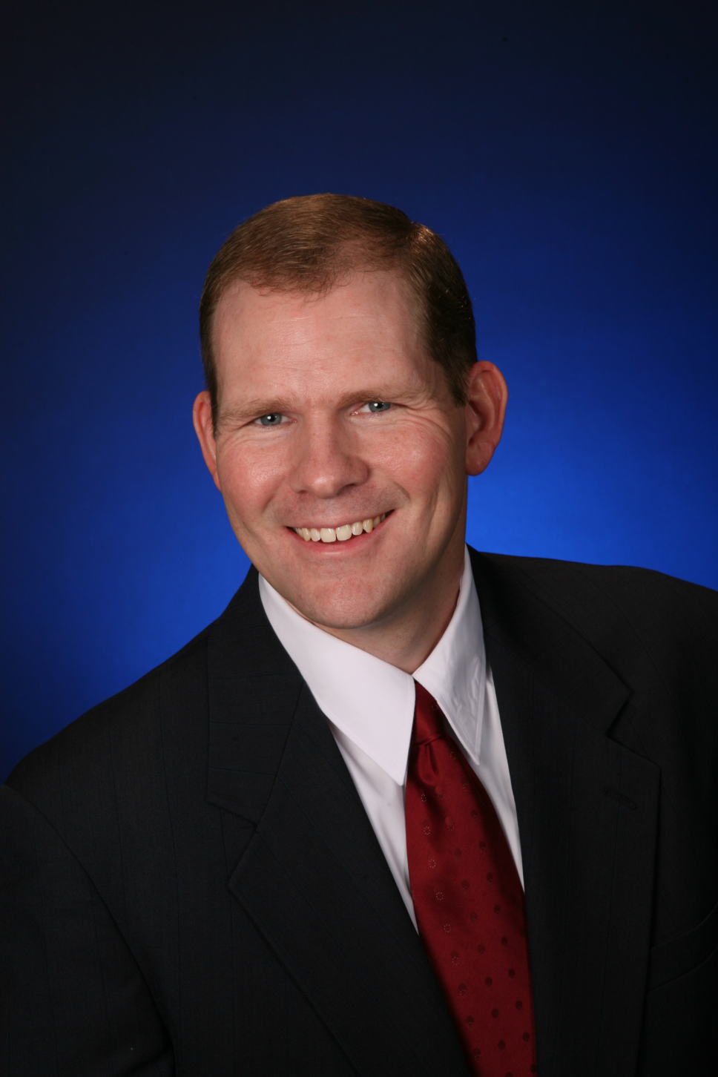  Lawsuits have been  initiated simply because  leaders simply  fail to offer an apology –  even when it is clearly the  right thing to do. Our  speaker will demonstrate  how that lack of civility has  severely cost business.

Doug Wajcieszak is a disclosure training consultant who has had several personal and professional
experiences with medical malpractice issues. He lost his oldest brother to medical errors in 1998 and his family
successfully sued the hospital and doctors with the case settling in 2000. The hospital attorneys – not the doctors –
apologized to Wojcieszak’s family, but only after the case was settled and money exchanged hands, and they
never admitted fault for the incident.

Around the same time his brother’s case was concluding, Wojcieszak became the Executive Director of
Illinois Lawsuit Abuse Watch (I-LAW), a grass-roots, pro-tort reform group. He was able to place over 200
positive stories about lawsuit abuse and capping lawsuit damages with various media in Illinois. During his time
with I-LAW, he studied full-disclosure methods for medical errors as a way to lower malpractice lawsuits and
liability costs as well as reduce medical errors.

After leaving I-LAW in 2001, Wojcieszak founded a consulting firm and began successfully promoting
apologies for medical errors as the solution to the medical malpractice crisis. He noticed that Sorry Works!, while
agreeable to many trial lawyers, also attracted the interest and support of many doctors and insurers. That lead
him to create the Sorry Works! Coaltion. It has grown quickly to over 3800 members nationwide, with the website
receiving over 4 million hits. The group’s efforts have been publicized in the Chicago Tribune, CNBC, the
Associated Press as well as time Magazine, National review, National Law Journal and American Medical
Association News.

JOIN OK ETHICS
- Join today – go to www.okethics.org or call 889-0498
- Do you know someone who has been laid off?
OK Ethics is offering a free Scout membership (value of $75) to any business professional who has been
recently impacted by a reduction-in-force. See the website or call 858-2233 for more details.

TULSA CHAPTER WELCOMES OUR FIRST INTERNATIONAL SPEAKER:
Management and Ethics in a Web 2.0 World & Beyond | January 28  Tulsa Southern Hills Marriott
The changes brought on by the internet revolution continue to redefine many aspects of our lives, both on the job and at home. The introduction of Web 2.0 technologies marks the beginning of a new phase in the evolution of the workplace that will have broad implications on how managers interact with their employees. Asher Adelman, a great workplace entrepreneur, will share some of these major trends and will discuss how blogs, social networking, and even Google will impact ethical dilemmas, define workplace relations, and alter the boss-employee relationship. His presentation will examine the threats that companies will encounter if they fail to recognize and adjust to these seismic changes.  Asher will also explore innovative workplace branding strategies that will help companies and managers prepare for these impending changes, gain a competitive advantage in their markets, and ensure the loyalty of their employees, customers, and shareholders. | 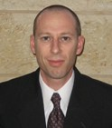  Asher Adelman  Founder of eBossWatch.com

VII. OTHER EVENTS RELATED TO INTEGRITY AT WORK
OK Ethics is honored by our friendship with the Character First! Institute.
They provided wisdom and the basis for our Guiding Principles.
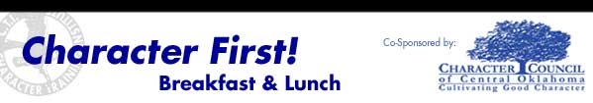
January 2010 - Resourcefulness:
Breakfast - Jan. 28, 2010 (Thursday)
Lunch - Jan. 28, 2010
Please RSVP by calling 815-0001 or Email for more information: blb@characterfirst.com
Cost is $10 per person

General Disclaimer: Members of the Oklahoma Business Ethics Consortium frequently share information concerning
various issues and developments that may have legal implications. The discussions, commentary, and handouts at
Consortium meetings or presentations to other organizations are for general informational purposes only. They cover
only some aspects of the subject topic, and do not constitute a complete legal analysis of the topic or how it
might apply to any particular set of facts. Before taking any action based on information presented during a Consortium
event, participants are encouraged to consult a qualified attorney. The observations and comments of presenters
at Consortium meetings and networking are the views and opinions of the presenter and do not constitute the
opinion or policies of the Consortium or any of its members. Presenters are respectfully requested to avoid profanity,
preaching, politics and self-promotion during their lectures.

