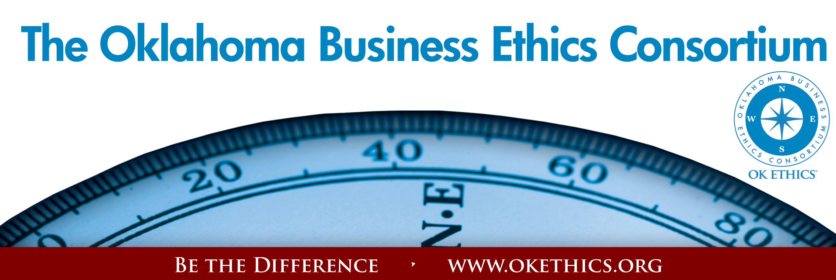

Oklahoma Business Ethics Consortium – July 15, 2009
Norman Chapter
I. Kudos to Our Volunteers:
Lisa Giles, Eide Bailly, LLP –
Registration & Chief Identification Officer
Special thanks to Deborah Gavula, Member Care Services

II. Introduction of Keynote Speaker Linda Streuhn, Ideal Homes

“WALKING THE TALK”
Vernon McKown, Ideal Homes
Vernon McKown is Co-owner and President of Sales of Ideal Homes of Norman, founded in 1990. Vernon is a frequent presenter at the National Builder's Show and EEBA Conference. He has served on a wide variety of philanthropic and charitable boards. He has a Bachelors Degree in Business Administration from the University of Oklahoma.
In its' 19th year of business, Ideal Homes built more than 500 new homes per year and $75 million in sales. They are the first Builder in America to get Energy Star for homes under $150,000, and they are also the first Builder in the state of Oklahoma to introduce guaranteed utilities. They have been recognized as one of the 101 Best Residential Construction Companies to work for in the United States. In 2007, Ideal was named America’s Best Builder.
Ideal Homes was an OK Ethics Compass Award recipient in 2008.

III. Upcoming Events Shannon Warren, OK Ethics Founder
August 25 | “Ethical Maturity”
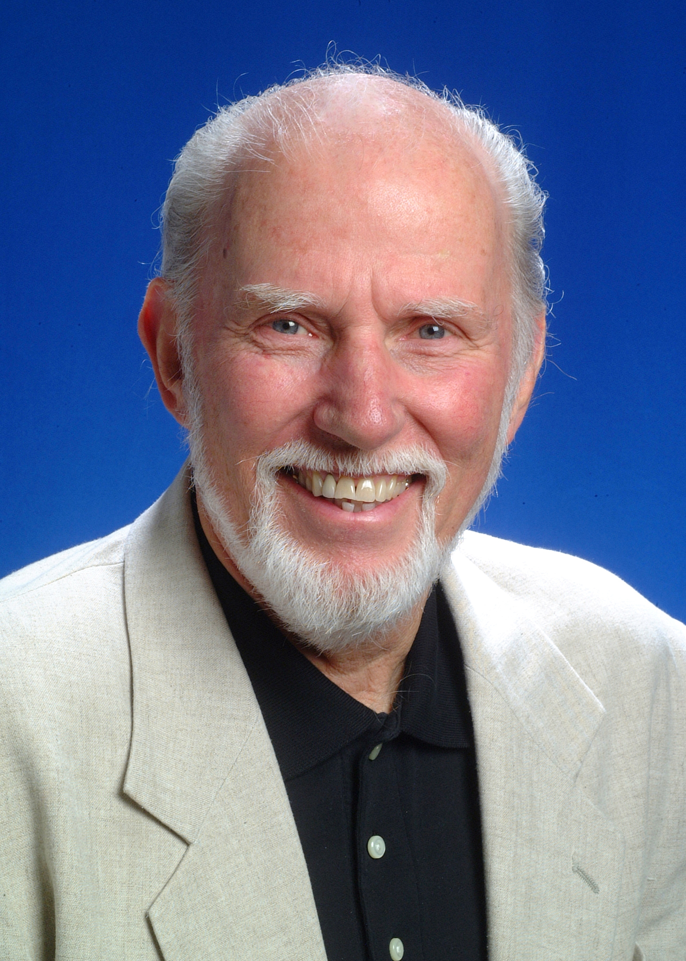Dr. Tom Boyd  University of Oklahoma | As individuals, we are constantly striving to evolve. While there are programs delving into emotional intelligence, this program will provide insights on developing  ethical maturity:  Doing the right thing for the right reasons.
OKC CHAPTER PRESENTS: (Note that OKC is taking summer break in June/July)

 | OKLAHOMA BUSINESS ETHICS CONSORTIUM  OKLAHOMA CITY CHAPTER PRESENTS  FALL SCHEDULE  Register Now!
August 12  11:30 – 1:00  “Guideposts for Gut-Wrenching Decisions”  Exploring the Ethical Implications of Layoffs: A program for healthy survivors  Recommended for 1 CPE in Ethics  R. Scott Griffin  Director of HR  SandRidge Energy  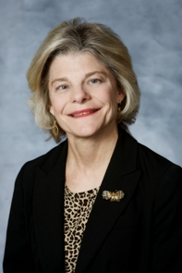  Cheryl French  Practice Leader  Gabbard and Company  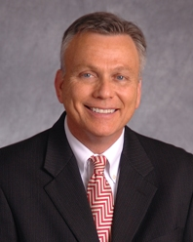  Jim Priest  Whitten, Burrage,  Priest, Fulmer,  Anderson, & Eisel | September 9  11:30 – 1:00  “The Speed of Trust”  Program will emphasize several key principles used in  Stephen Covey's latest book.  Recommended for 1 CPE in Ethics  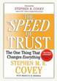  Presented by William J. Siems,  Certified Covey trainer  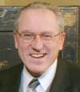 | October 14  11:30 – 1:00  John Richels  President  Devon Energy  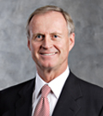  REGISTER  FOR ALL EVENTS  AT  WWW.OKETHICS.ORG

TULSA EVENTS

September 24 | “How to Develop Productive & Loyal Employees”
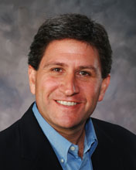 | Presented by Chet Cadieux  Chief Executive Officer  QuikTrip

Character First Institute:
OK Ethics is honored by our friendship with the
Character First! Institute.
They provided wisdom and the basis for our Guiding Principles.
For more information on upcoming Business and Community Leaders' Luncheon, please contact them at 815-0001, or visit www.characterok.org./
Cost is $10 per person. The next topic is
“Faith in the Workplace” to be presented on
Tuesday, July 28 and Thursday, July 30.
Faith vs. Presumption
Confidence that actions rooted in good character will yield the best outcome, even when I cannot see how
Faith overcomes uncertainties by weighing what is known against what is not known. As you base decisions on proven principles, you can confidently pursue the process before you, instead of trying to manipulate results. When you face a difficult decision, consider everything you know, observe, or have experienced; consult with others; determine what is right; and move forward.
"Every great enterprise begins with and takes its first forward step in faith." —Friedrich von Schlegel

General Disclaimer: Members of the Oklahoma Business Ethics Consortium frequently share information concerning various issues and developments that may have legal implications. The discussions, commentary, and handouts at Consortium meetings or presentations to other organizations are for general informational purposes only. They cover only some aspects of the subject topic, and do not constitute a complete legal analysis of the topic or how it might apply to any particular set of facts. Before taking any action based on information presented during a Consortium event, participants are encouraged to consult a qualified attorney.

The observations and comments of presenters at Consortium meetings and networking are the views and opinions of the presenter and do not constitute the opinion or policies of the Consortium or any of its members. Presenters are requested to avoid profanity, preaching, politics and self-promotion during their lectures.

