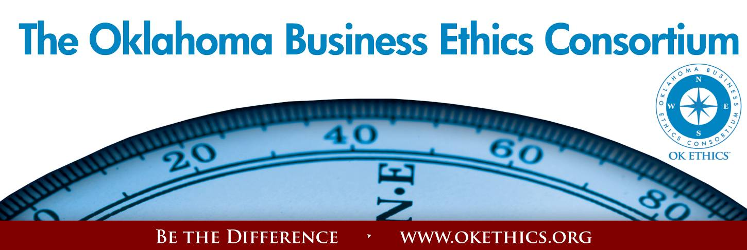
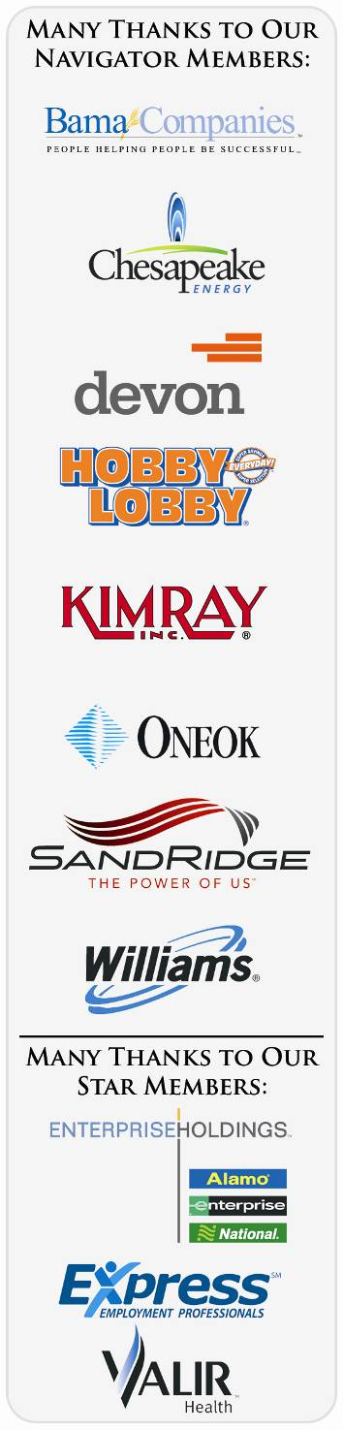
Agenda – March 7, 2012
- Welcoming Remarks & Kudos – Myrna Schack Latham, Attorney
McAfee & Taft; General Counsel - OK Ethics Board of Directors
II. Intentional Interaction - Shannon Warren, Founder, OK Ethics
a. Have you ever been asked to do something that seemed unethical?
b. What’s the most tactful way to respond to a such a request:
From a co-worker? Boss?
Note: OK Ethics encourages interaction among our members for the purpose of
building relationships with others who share an interest in promoting Oklahoma values of integrity at work. At the same time, this is not an appropriate forum for sales activities.
- “Upcoming Events” - Jim Priest, Executive Director of F.A.T.E.
- Introduction – Joy LaBar, Vice President of Audit, SandRidge Energy
- Keynote - “The Slippery Slope” - David Myers,
Former WorldCom Controller
- Adjourn

Congratulations to The University of Oklahoma – Placed 9th at the National Ethics Bowl last week. Competed against 31 other teams from across the country. Was within 3 points of winning! The ONLY Oklahoma team ever to place! Congratulations to Dr. Steve Ellis, team advisor and his students.

ANNUAL COMPASS AWARDS - Deadline for Applications March 22
International speaker Stephen M. R. Covey is the New York Times and #1 Wall Street Journal bestselling author of The Speed of Trust: The One Thing That Changes Everything. He is the former CEO of Covey Leadership Center, which, under his stewardship, became the largest leadership development company in the world and today, as FranklinCovey, teaches trust in more than 100 countries.
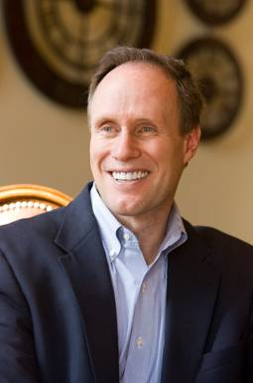 | APRIL 18  COMPASS AWARDS  Featuring  STEPHEN M. R. COVEY  10% Early Bird Discount  Honoring Larry Nichols,  Devon Energy  Executive Pilot Recipient | 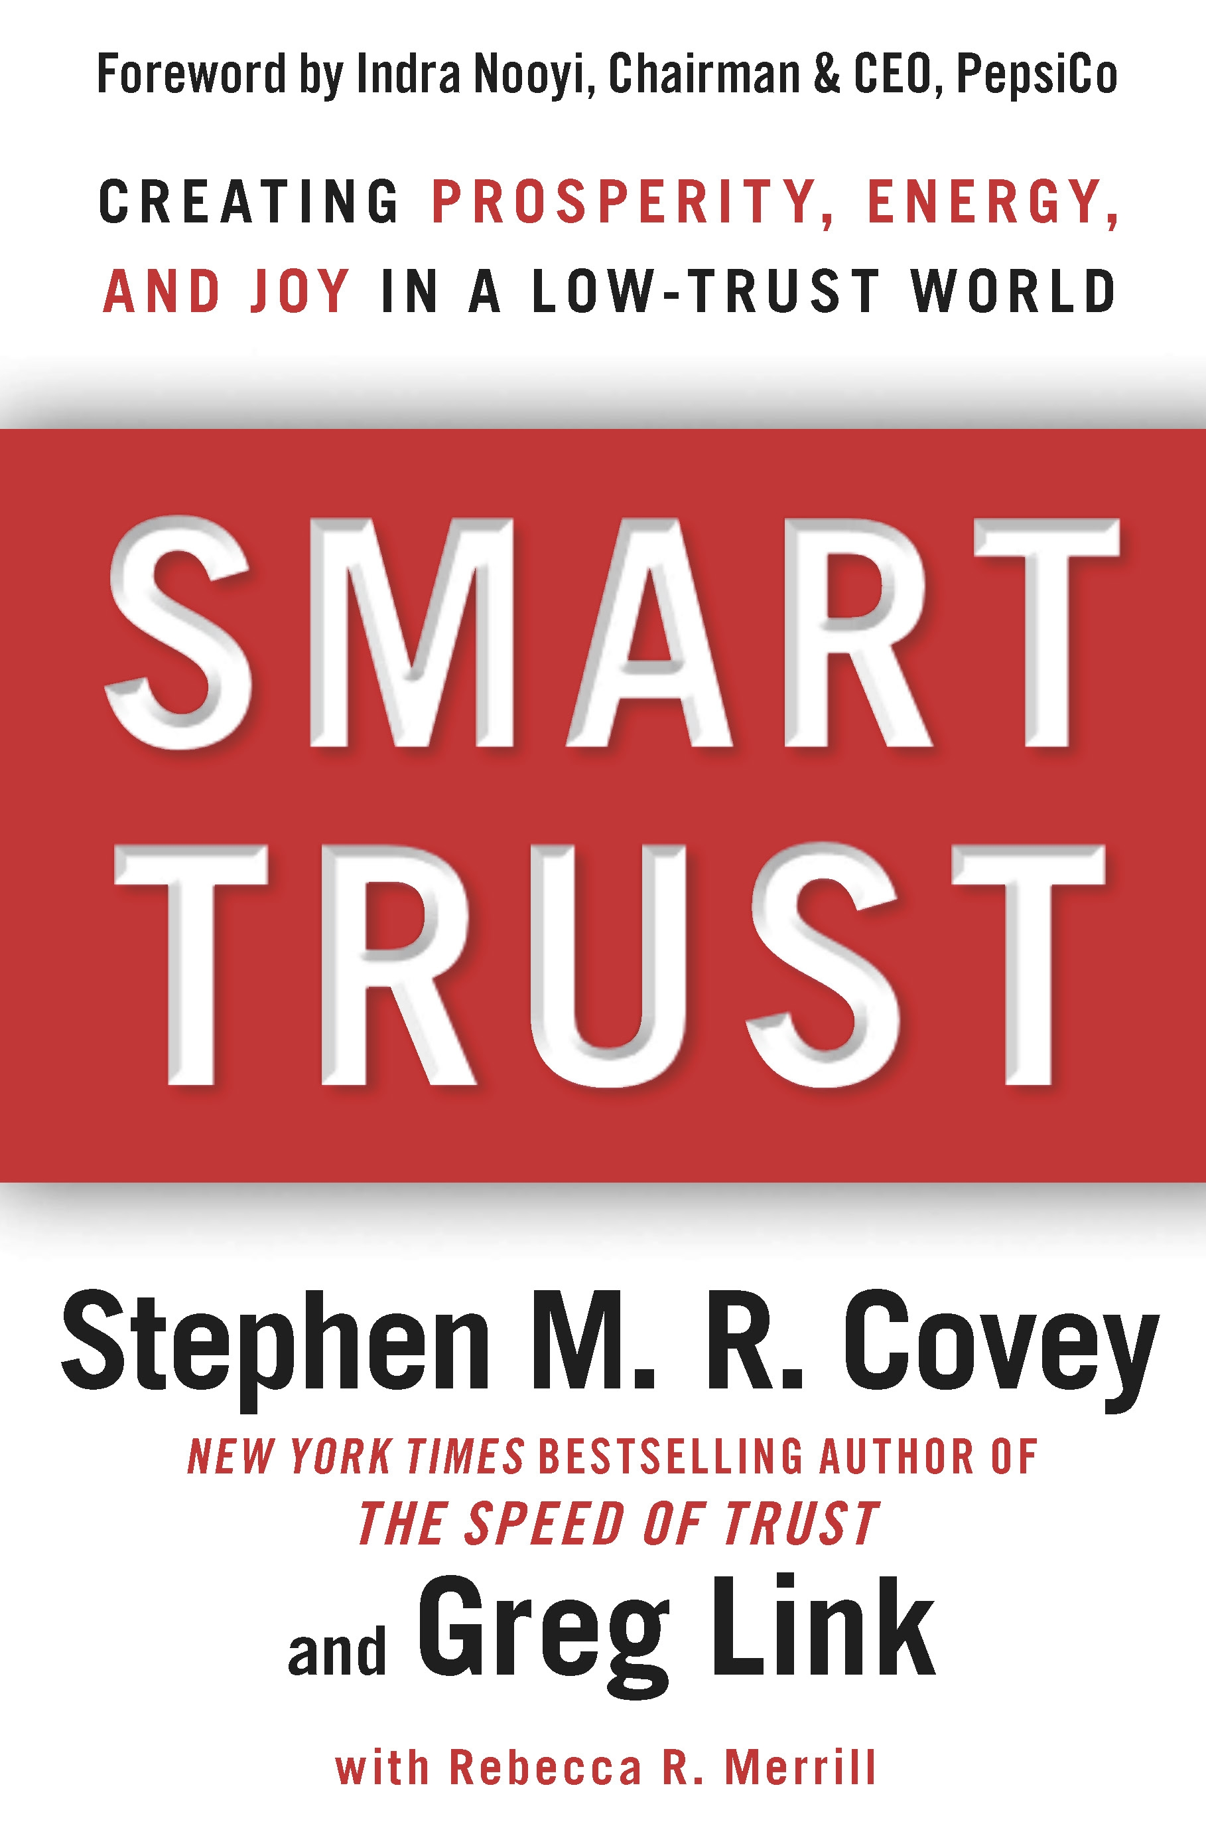

VOLUNTEER RECOGNITION:
OK Ethics relies primarily on volunteers to achieve the organization’s successful pursuit of Oklahoma’s values of integrity at work. However, the expanding operations required a more consistent approach.
Registration Team: These dependable individuals show up every month to diligently record
our guests’ attendance and handle the collection of fees:
- Mark Neumeister, Chairperson; D. R. Payne & Associates:
Join our team - Contact our leadership
Membership & Recruiting: Shannon Warren, Founder, OK Ethics
warrenokla@cox.net or 858-2233
Ambassadors: Linda Streun, Director of Human Resources,
Ideal Homes, lindastreun@ideal-homes.com
Registration: Mark Neumeister, D. R. Payne; 272-0511; moneumeister@drpayne.com
  - Mary Vaughn, CPA
- Joe Walker, Chairperson (Prepaid members); Wilbanks Security
  - Brandon Weldon, SandRidge Energy
Ambassador Team: These friendly people welcome our guests each month and assist in helping them locate seats. They also arrive early to help distribute agendas and assist with name tags.
Team Leaders:
- Linda Streun, Ideal Homes of Norman: Chairperson
Team Members:

- John Burnett – Character First
- Chris Ferguson - Oklahoma Funeral Board
- Jamie Gorman- Hyde and Company
- Claudette Greenway - OU Medicine
- Valorie Hodges – Valir Heatlh
- Jacob Pasby – Grant Thornton
- Bobby Redinger – Cole & Reed
- Bill Turner – Valir Health
- Daniel Yunker – Kimray, Inc.

Agendas: Metro Technology Centers, Quality Services and Media Departments
Accounts Receivable Reconciliation: Susan Pate, Stinnett & Associates
CPE’s: Michael Mount, CPA, Oklahoma Accountancy Board
Facilities & Logistics: Jamie Potter, Eide Bailly
Name tags: Sue Miller, Accel Financial Services
Member Care Coordinator: Jalisha Petties, Accounting Principals
Pre-meeting slide show: Connie Rutz, Maximum Multimedia Creations
National Ethics Bowl: Colin Schoonover, ONG
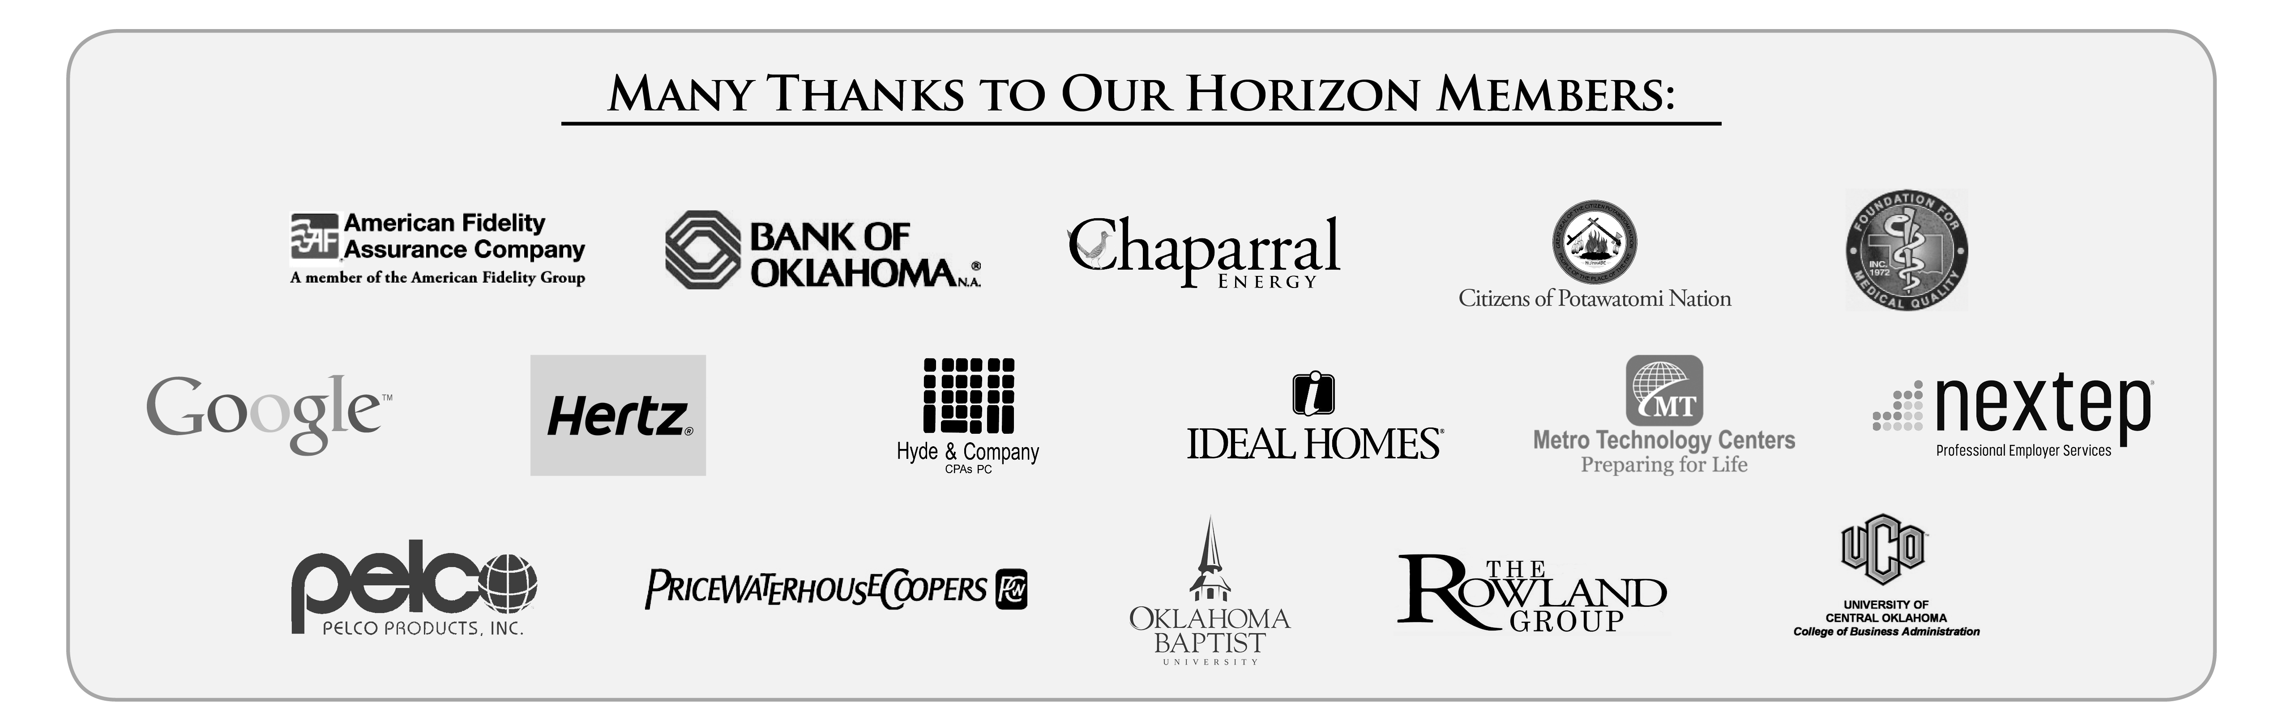
UPCOMING OK ETHICS EVENTS: OKLAHOMA CITY CHAPTER
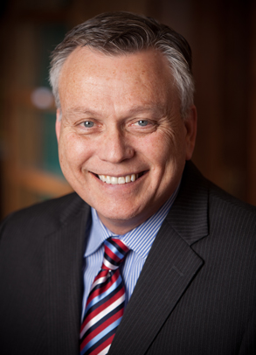  Jim Priest is a husband, dad, attorney and ordained minister in the Church of the Nazarene. He has practiced law in Oklahoma for over thirty years and has been consistently recognized as one of the best lawyers in the nation. In February 2011, Jim became the Executive Director of the non profit organization FATE (Fighting Addiction Through Education) www.fate.org. | May 9  “An Ethical Approach to Substance Abuse”  Professor Steven Mintz, founder of the website, Workplace Ethics Advice, writes: “I teach my students about business ethics and social responsibility. Businesses have a responsibility to provide for a safe workplace and to deal quickly and effectively with behaviors that potentially harm an employee, fellow employees, and those in the community. Providing for an alcohol and substance abuse-free workplace requires a commitment to ethical behavior.”  An ethical approach to substance abuse in the workplace requires more than a drug testing program and firing employees who flunk. So how do you do it? How do co-workers deal with fellow employees who use-- without feeling like a "snitch"? This presentation will provide you with “the ol’ how-to” and will raise your consciousness, lower your fears, and cement your resolve to take the initiative in dealing ethically and effectively with substance abuse.
UPCOMING OK ETHICS EVENTS: TULSA CHAPTER
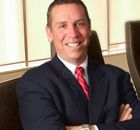 | "Doubting, Worrying & Wondering:  The path to ethical decision-making is awareness"  Professor Urich is concerned about the trend among people who stand up in society and tell others how to behave -- they sometimes are embarrassed, disgraced or arrested. In studying the complexity of ethical decision-making, he has identified awareness as the key factor. As an ordinary person, trying to be ethical, Andrew will argue that doubting, worrying and wondering is truly the best strategy to avoid embarrassment, disgrace and arrest.  Bonus: As part of Professor Andrew Urich's research on ethical decision making, he stumbled upon the secret to happiness. You will not want to miss Professor Urich's entertaining and engaging presentation.
Professor Andrew Urich, JD  May 24, 2012 | Puterbaugh Professor of Ethics and Legal Studies  Spears School of Business, Oklahoma State University

Program is being taped for access via the OK Ethics website. Watch for details.
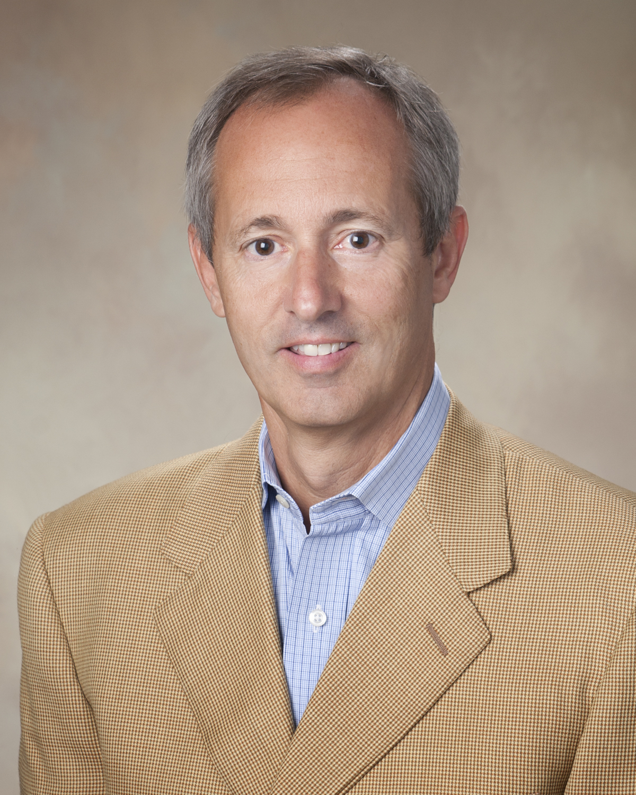  David Myers  Currently Myers is an owner and the CFO of Sunflower Home Health serving 11 counties in the MS Delta.  Myers donates a substantial amount of time speaking to various organizations about the lessons learned during his experience while at WorldCom as well as the dire consequences his decisions had on not only his family but the lives of so many others. | March 14, 2012  “The Slippery Slope”  David Myers  Former WorldCom Controller  Recommended for 1 CPE in Ethics  About our presenter…  Key Events in Myers’ Time at WorldCom:  - 1995 joined WorldCom as a Vice President and Treasurer.  - 1997 promoted to Senior Vice President and Controller managing a global staff of over 2,000.  - 1995 through early 2002 was a key participant in large scale debt and equity financing transactions as well as mergers and acquisitions which resulted in WorldCom growing to one of the largest telecom companies in the world.  - June 24, 2002, at WorldCom’s Audit Committee’s insistence, Myers resigned his position as a Senior Vice President and the Controller of WorldCom, Inc.  - August 1, 2002, the United States Department of Justice filed a criminal complaint against Myers for his role in the accounting fraud at WorldCom.  - September 26, 2002, Myers pled guilt to three felony counts and became a cooperating witness for the government in the trials of other WorldCom executives.  - August 10, 2005, Myers was sentenced to serve one year and a day in a federal correctional facility.  Prior to joining WorldCom, Myers served as the CFO and Treasurer of Lamar Life Insurance Group. Prior to Lamar, Myers was as a Senior Audit Manager with Ernst & Young, in its Houston, TX and Jackson MS offices.  Myers received a Bachelor of Accountancy and a Bachelor of Business Administration in Marketing from the University of Mississippi.  Myers is married to the former Lynn Hobbs, a former Taylor Medalist and graduate of the School of Accounting at the University of Mississippi. He is the father of four children.

Think that this could never happen to you? Think again...
This family man never dreamed he would play a hand in a $3.8 billion fraud case - one of the worst in U.S. history. When David Myers graduated from Ole Miss with a degree, his career was on the fast track. He joined WorldCom in 1995 and was a rising star. In 2002, when the scandal broke, he held the position of Senior Vice President and Controller, leading a global staff of over 2000.
David was convicted of three felony counts and became a key witness in the government's case. In 2005, he began serving a year's time in a federal facility. Today, David donates a considerable amount of time speaking to groups about the lessons he learned. A compelling message for all of us.

“The Slippery Slope: No Way That Could Happen to Me!”

I. The Early Years
- Brought up in a Christian-based family
- Attended a Baptist Academy
- Attended Ole Miss with degrees in Marketing and Accounting
II. Public Accounting Years
- Began with Ernst & Whinney (now Ernst &Young in Houston, TX) as a little fish in a big pond, but did very well
- Moved back home to Jackson, MS with new managing partner as a big fish in a little pond and ran all of the top jobs focusing on SEC registrants

III. Post Public Accounting
- Left E&Y to become CFO of Lamar Life
- Insurance Company, the oldest insurance
- company in MS
- After unsuccessful IPO (due to change in market conditions) sold the business to an out-of-state insurance company consolidator
- This experience was first real indicator of how people can manipulate others

IV. Made it to the Big Time
- After the sale of Lamar was asked to interview at WorldCom
- Had previously turned down three previous offers over the past 10 years
- Meetings with Scott Sullivan and Bernie Ebbers before I accepted the position of Treasurer

V. WCOM
Chapter One
- Key Participant in many Acquisitions including WilTel based in Tulsa
- Led relationships with consortium of 120+ international banks
- Led effort for world’s largest public bond offering
- Heard Bernie’s speech in first month that should have told me what to expect

VI. WCOM
Chapter Two
- As a result of the acquisition of MFS, changed from Treasurer to Controller
- Immediately saw the soft underbelly that no one mentioned before
- Another signal ignored

VII. WCOM
Chapter Three
- The impact of the Dot-Com crash
- The public response
- The real answer
- The entire game changed and my world began to crumble
- Another signal ignored

VIII. WCOM
Chapter Four
- 3rd Quarter 1999 is when the world turned upside down
- Convinced by Sullivan that I had made a huge mistake
- Posted a “top side” entry to get to what
- Sullivan knows is the right answer and find out where you screwed up later
- The mistake was not mine. I wish it had been.
- The slippery slope is steep too!

IX. WCON
Smoke and Mirrors
- The following year was spent eliminating reserves built up over 200 acquisitions and reducing line cost.
- Really bad accounting or fraud?
- How could the auditors never see what was happening?

X. WCON
Move from Bad Accounting to fraud
- Once the excess liabilities were drained the mushroom cloud began to form
- Capitalize line cost without justification
- Forgot to mention to the auditors that this was all done in “top level” entires they did not see
- I repeat, “how did they not see it?”

XI. WCON
The End
- Sprint acquisition is denied by EU
- Scared employees tell Internal Audit
- Internal Audit tells the auditors and still they do nothing
- Internal Audit does the right thing
- Internal Audit confronts my staff and then me
- Lights Out

XII. Post WCOM/WCON
- Spent months trying to find a lawyer to plead guilty
- Working with the US Attorneys and the FBI
- The trial against Sullivan
- Sullivan turns on Bernie
- The trial against Bernie

XIII. Adult day care
- Prison for a person with the previous worst offense being a traffic fine
- Life in prison...lessons learned and taught

XIV. Life anew
- Odd jobs and life reshaped
- Years of building back what I lost or better said “gave away”
- Helping Others proved to be of more help to me once I opened my eyes and started breathing again
- My first speech was with the Prosecutor

XV. Today
- To be continued

General Program Disclaimer:
Members of the Oklahoma Business Ethics Consortium frequently share information concerning various issues and developments that may have legal implications. The discussions, commentary, and handouts at Consortium meetings or presentations to other organizations are for general informational purposes only. They cover only some aspects of the subject topic, and do not constitute a complete legal analysis of the topic or how it might apply to any particular set of facts. Before taking any action based on information presented during a Consortium event, participants are encouraged to consult a qualified attorney. The observations and comments of presenters at Consortium meetings and networking are the views and opinions of the presenter and do not constitute the opinion or policies of the Consortium or any of its members. Presenters are respectfully requested to avoid profanity, preaching, politics, put-downs and self-promotion during their lectures

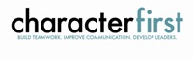
Programs Focused on Integrity - (Not affiliated with OK Ethics)
For nearly nine years, we have been inspired by our friendship with Character First. Leaders with this organization provided the wisdom and insight for OK Ethic's Guiding Principles. Go to www.characterfirst.com to learn more about tools to help you integrate character and ethics into your organizational culture, or contact John Burnett at 405-815-0001

“Preventing Workplace Harassment”
Character First Full-Day Leadership Seminar
Thursday, April 19, 2012 | Oklahoma City
Harassment comes in many forms—including bullying, bribery, and blackmail. Learn how to develop a workplace culture that prevents harassment before it starts, catches it when it occurs, and responds in ways that address the character issues, not just the action.

Character Council of Central Oklahoma …cultivating good character
The Character Council of Central Oklahoma is an organization that educates, equips and empowers others to create a culture of good character within Central Oklahoma. Their vision is that Central Oklahoma will become a model community of good character. Upcoming programs include:
March 27: Lew Sterrett - Founder, Sermon on the Mount
April 24: Tony Kennedy – President, Oklahoma Baptist Home for Children
May 22: James Lankford – Representative, United States Congress
Cost is $15 per person; Reservations made via luncheon@characterok.org

Hats off to Oklahoma’s future - our students:
- The Men of Distinction (MOD SQUAD) leadership group of Metro Career Academy with Metro Technology Centers
- Oklahoma Baptist University
- Southern Nazarene University
- The University of Central Oklahoma

Oklahoma Business Ethics Consortium Guiding Principles
Adopted July, 2004
To ensure that the Consortium fosters positive characteristics of integrity in the successful achievement of its goals, these Guiding Principles were discussed and adopted (with revisions) during a milestone planning session held by Consortium leaders in Stroud on June 18, 2004. These principles were developed based on the Character First Institute's values and philosophies.
I. Responsibility to Self and Others:
- Service:
  - Passion for promoting ethics and integrity
  - Encouraging the promotion of ethical behavior through personal actions and
  - Sharing ideas and resources
  - Responsibility and accountability for fulfilling the mission of the Consortium.
- Collaboration:
  - Achievement of common goals through the promotion of ethical, mutually beneficial relationships
  - Service to the Consortium over promotion of self-interest
  - Cooperation emphasized over competition in promoting ethical business conduct
  - Members collaborate by being constructively engaged in discussions regarding ethics
  - Seeking consensus in interactive discussions regarding ethical matters.
- Respect:
  - Members may become aware of confidential information shared by others in an effort to determine an ethical course of action. We ask members to be sensitive in recognizing and respecting the efforts made toward achieving ethical behavior. In that vein, public disclosure of this information is discouraged.
  - We respect other members and the process by:
    - Exhibiting listening skills and actively listening to discussions
    - Being open to other points of view and outcomes
  - We are an inclusive organization and demonstrate this by welcoming members who are in different stages of learning as applied to ethical behavior.
II. Lead with Integrity
- Dependability:
  - Members are asked to demonstrate their support of this initiative by consistently attending meetings.
- Initiative:
  - Recruiting other members who have demonstrated a desire to promote ethical behavior in their organizations.
  - Recognizing what needs to be done to help promote the Mission of the Consortium and taking action to assist in that effort.
- Honor:
  - Members are asked to honor the Consortium through the practice of integrity and ethical behavior in their business dealings.
  - We express gratefulness to our hosts, sponsors and speakers; as well as to those whose volunteer service makes OK Ethics a stronger organization.
  - Realizing that each of us is in a mode of continual learning, we demonstrate humility, care and compassion when sharing our thoughts and knowledge.
- Courage:
  - Speak the truth with confidence and encourage others to do the same.
III. Inspire Trust
- We serve and promote the cause of truth with integrity, objectivity and fairness to all persons.
  - We hold ourselves accountable by consistently honoring our word.
  - We extend trust abundantly to those who have earned it.
  - Trust, once earned, will not be taken for granted, manipulated or abused.

