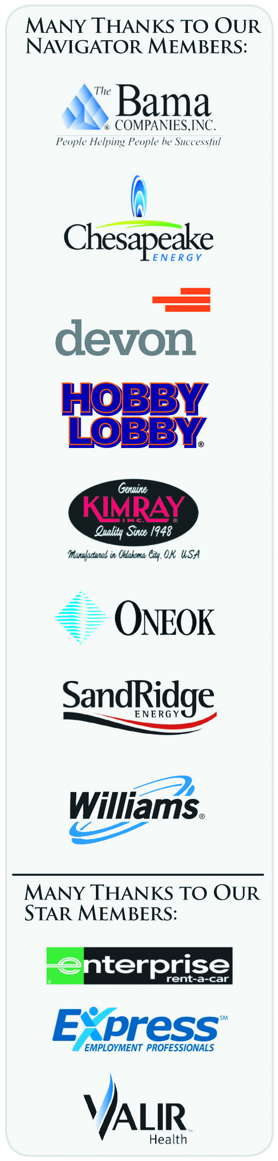
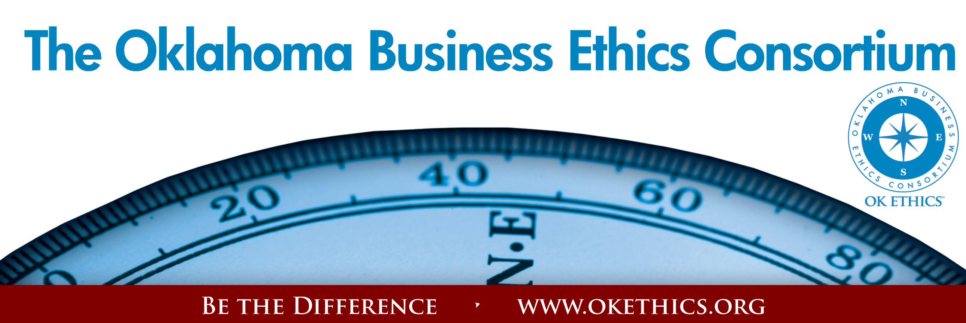

Tulsa Chapter
Meeting Agenda
July 15, 2010

- Welcome Nick Minden, Chapter President

- Guiding Principle Michael Oonk, Membership Chair

- Panel Discussion

"LIAR LIAR"
A panel discussion on the prevalence of lying in society and the business world.

Panelists
Dr. Chris Wright Ms. Julie Hakman Mr. Doug Cash
President & CEO President Manager
Reliant AmericanChecked Eide Bailly

- Q&A

Many thanks to our volunteers and Legacy team members for making this and every other meeting possible: Kevin Kennemer, Jan Laub, Jennifer Lyon, Carol Swarthout, Lynn Flinn, John Stancavage, Michael Oonk, James Kelley, Tom Clatfelter, Rhonda Bailey, David White, Shere Rockwell and Royce Kelly.

General Disclaimer: Members of the Oklahoma Business Ethics Consortium frequently share information concerning various issues and developments that may have legal implications. The discussions, commentary, and handouts at Consortium meetings or presentations to other organizations are for general informational purposes only. They cover only some aspects of the subject topic, and do not constitute a complete legal analysis of the topic or how it might apply to any particular set of facts. Before taking any action based on information presented during a Consortium event, participants are encouraged to consult a qualified attorney. The observations and comments of presenters at Consortium meetings and networking are the views and opinions of the presenter and do not constitute the opinion or policies of the Consortium or any of its members. Presenters are respectfully requested to avoid profanity, preaching, politics and self-promotion during their lectures.

