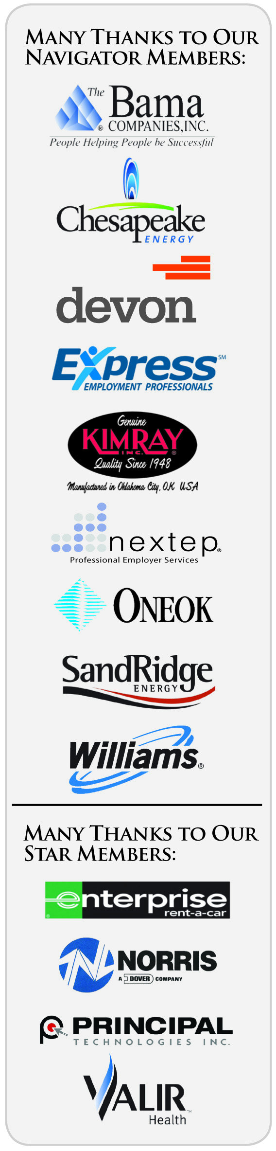
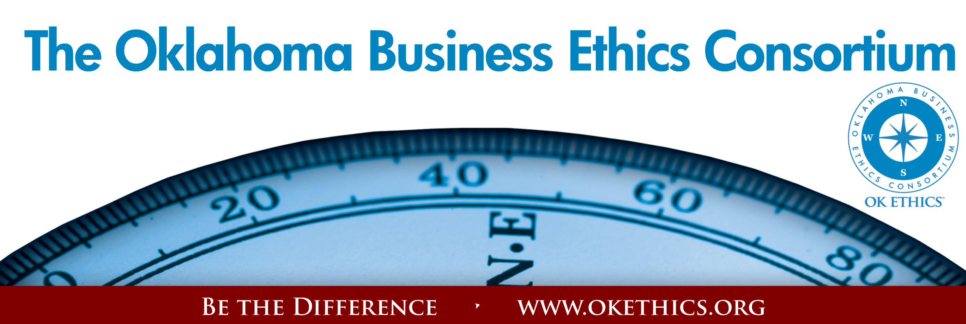
ANNUAL COMPASS AWARDS - APRIL 29, 2009
- Welcome & Kudos Lynn Flinn,
OK Ethics Tulsa Chapter Founder
President - The Rowland Group
- Introduction of Lieutenant Governor Garyl Geist,
President - OK Ethics Consortium Board of Directors
Chief Executive Officer - Valir Health
- Opening Remarks Lieutenant Governor Jari Askins
- OK Ethics Foundation Bob Byrne,
President – OK Ethics Foundation
Ethics Advisor – Boeing

▪ Statewide Student Ethics Challenge
A special thanks to Enterprise Rent-A-Car for the $2500 grant that will be used to help defray travel costs for Dr. Barbara Crandall (OCU) and Dr. Katherene Terrell (UCO) to participate in the regional ethics bowl to be held in Texas on November 14. They were chosen by the OK Ethics Foundation Board for their sustained efforts, dedication and enthusiasm for the ethics challenge events over the years.
▪ Scholarship Awards
The Bama Companies, Inc. | Enterprise Rent-A-Car
Kimray, Inc. | ONEOK
Principal Technologies Inc. | Valir Health
Chesapeake Energy-  Tony Blasier  ▪ Bridget Shuck,  Oklahoma City University | Norris –  Tramaine Ingram  ▪ Tiffany Thompson;  Douglass High School
Devon Energy –  Janice Dobbs  * Candace Jordan,  The University of Oklahoma | SandRidge Energy –  Mary Whitson  ▪ Courtney Vieta,  University of Central Oklahoma
Express Employment Professionals –  Susan Zabel  ▪ Matthew Maupin,  The University of Oklahoma | Nextep – Brian Fayak  ▪ Olga Mironova,  University of Central  Oklahoma
The Williams Companies -
Tony Gehres
▪ Robin Chipman,
University of Central
Oklahoma

V. Founders Circle Awards Jim Priest - Founding Member of OK Ethics
Attorney - Whitten, Burrage, Priest, Fulmer, Anderson & Eisel

(See last page for Founders Circle Honorees)

VI. OK Ethics Compass Awards Presentations Mike Strong
Chairperson, Compass Awards Selection Team
Executive Director - Oklahoma Quality Award Foundation
• The Surveyor’s Compass
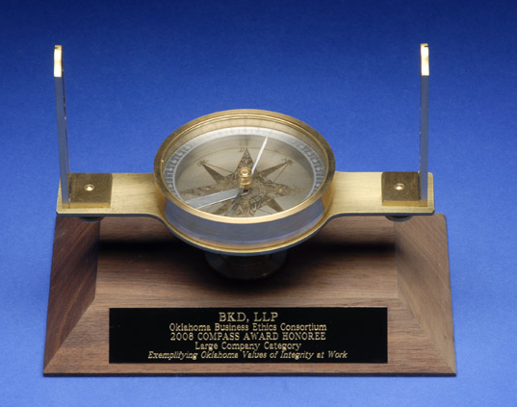
Donated by Burk Cornelius of the Oklahoma Society of Land Surveyors, this is a replica of an instrument dating back to the 1700’s. While it has been a tool used for surveying for many years, the compass is used to guide one’s course – making it the perfect symbol for the OK Ethics Compass Award.

• Recognition of Past Compass Award Recipients
2008: BKD, LLP ~ Ideal Homes of Norman ~ Principal Technologies, Inc.
2007: Boeing ~ The Bama Companies, Inc ~ Coppermark Bank ~ Nextep, Inc.
2006: Eide Bailly ~ Valir Health
VIEW APPLICATIONS FROM PAST RECIPIENTS AT WWW.OKETHICS.ORG – “Compass Awards”

• Introduction of Selection Panel

- Mid-Sized Company Category Edith Steele
Charter Member, Compass Awards Selection Team
Executive Director – Oklahoma Accountancy Board
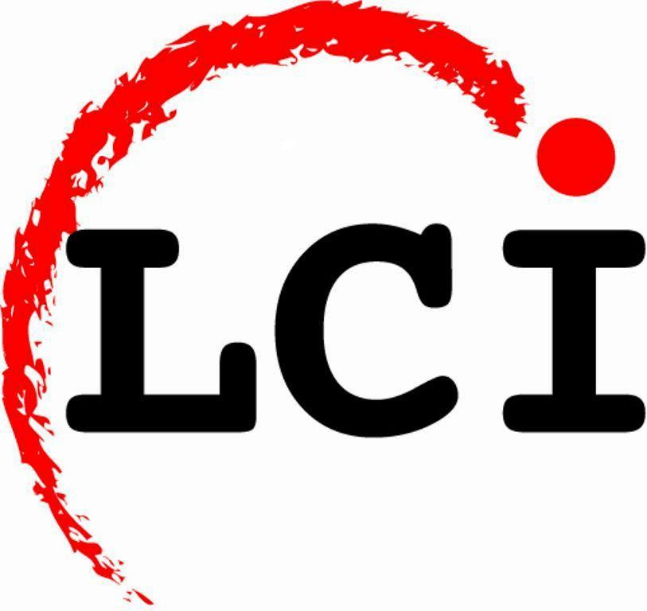
Honoree: Leader Communications, Inc. - Mike Lyles, President/CEO

- Large Company Category Oscar Jackson
Charter Member, Compass Awards Selection Team
Administrator – State of Oklahoma Office of Personnel Management

Cabinet Secretary – Human Resources & Administration
Honoree: Chesapeake Energy Corp.
Martha Burger, Vice President of Human Resources

VII. Introduction of Keynote Speaker
Myrna Schack Latham
General Counsel, OK Ethics Board of Directors
Shareholder - McAfee & Taft

VIII. Keynote Speaker Sherri Coale, Women’s Basketball Coach
The University of Oklahoma

IX. Upcoming Events Shannon Warren, Founder
Oklahoma Business Ethics Consortium

General Disclaimer: Members of the Oklahoma Business Ethics Consortium frequently share information concerning various issues and developments that may have legal implications. The discussions, commentary, and handouts at Consortium meetings or presentations to other organizations are for general informational purposes only. They cover only some aspects of the subject topic, and do not constitute a complete legal analysis of the topic or how it might apply to any particular set of facts. Before taking any action based on information presented during a Consortium event, participants are encouraged to consult a qualified attorney. The observations and comments of presenters at Consortium meetings and networking are the views and opinions of the presenter and do not constitute the opinion or policies of the Consortium or any of its members. Presenters are respectfully requested to avoid profanity, preaching, politics and self-promotion during their lectures.

REGISTER FOR ALL EVENTS AT WWW.OKETHICS.ORG

OKLAHOMA CITY CHAPTER PRESENTS:

May 20
OKLAHOMA BUSINESS ETHICS CONSORTIUM’S FIRST NATIONAL AWARD
National Association of the State Boards of Accountancy
Center for Public Trust Award
“Being The Difference”
Keynote Speaker: Larry Bridgesmith, NASBA Board of Directors
Executive Director, Institute for Conflict Management, Lipscomb University
Topic: “Ethics & Resolving Inter Interpersonal Conflict”
1 CPE OFFERED – NASBA - NATIONAL REGISTRY

MOORE-NORMAN CHAPTER PRESENTS:
June 17 | August 25
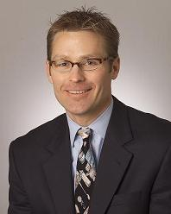  Vernon McKown  Ideal Homes  of Norman | 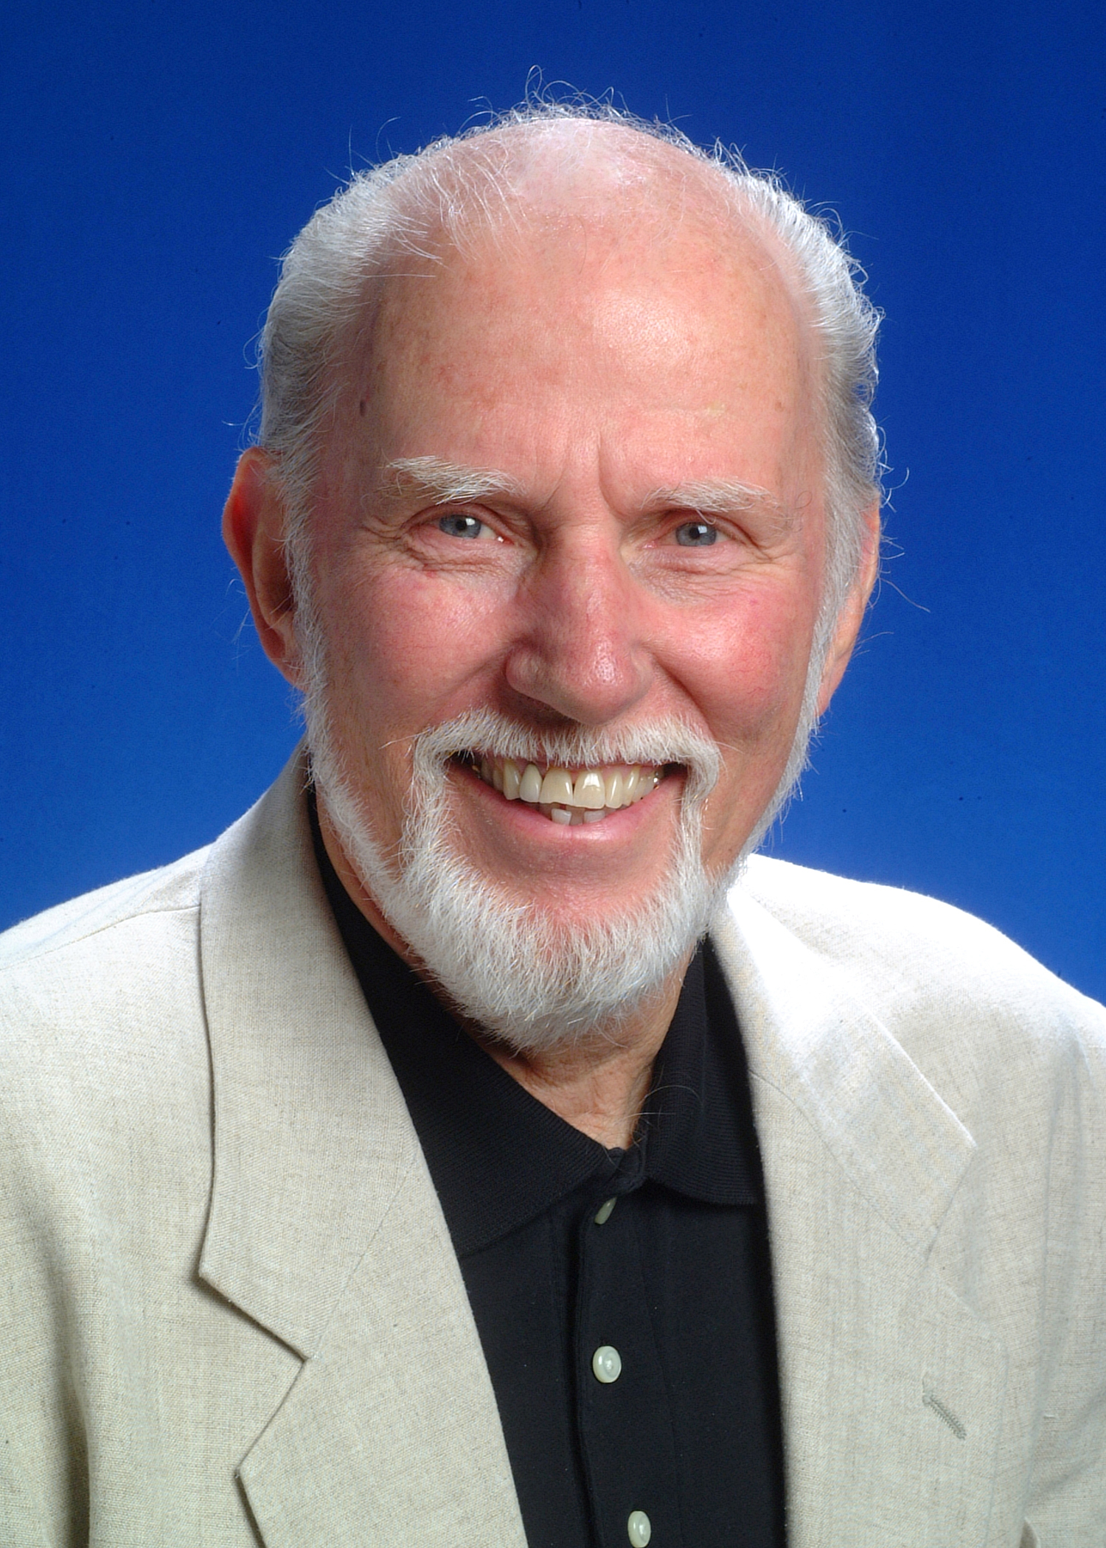  Dr. Tom Boyd  University of Oklahoma
 | “Ethical Maturity”  As individuals, we are constantly striving to evolve. While there are programs delving into emotional intelligence, this program will provide insights on developing  ethical maturity:  Doing the right thing for the right reasons.  Tom W. Boyd is the David Ross Boyd Professor Emeritus of Philosophy at the University of Oklahoma. After teaching philosophy of religion and ethics there for 28 years, he retired from fulltime teaching in 1997. He also retired from the ordained ministry in the Presbyterian Church USA in the summer of 1998.  Tom holds four earned degrees, including a Ph.D. in Religion from Vanderbilt University in 1973. His academic specialization is in philosophical theology, theories of religion, religion and culture, and ethics. His current concentration is on the relation among world religions and the relation between religion and culture. He also studies the impact  of religion on ethics.
  Vernon McKown is Co-owner and President of Sales of Ideal Homes of Norman, founded in 1990. Vernon is a frequent presenter at the National Builder's Show and EEBA Conference. He has served on a wide variety of philanthropic and charitable boards. He has a Bachelors Degree in Business Administration from the University of Oklahoma.
  In its' 19th year of business, Ideal Homes built more than 500 new homes per year and $75 million in sales. They are the first Builder in America to get Energy Star for homes under $150,000, and they are also the first Builder in the state of Oklahoma to introduce guaranteed utilities. They have been recognized as one of the 101 Best Residential Construction Companies to work for in the United States. In 2007, Ideal was named America’s Best Builder.

OKLAHOMA CITY EVENTS (Continued):
September 9  “The Speed of Trust”  Based on Stephen Covey’s latest book  Presented by  William J. Siems, Boeing  Certified Covey Trainer  Recommended for 1 CPE in Ethics | 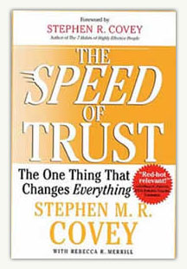

TULSA EVENTS
May 28 | “The Ethics of Layoffs”

September 24 | “How to Develop Productive & Loyal Employees”
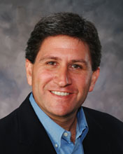 | Presented by Chet Cadieux  Chief Executive Officer  QuikTrip

REGISTER FOR ALL EVENTS AT
WWW.OKETHICS.ORG

